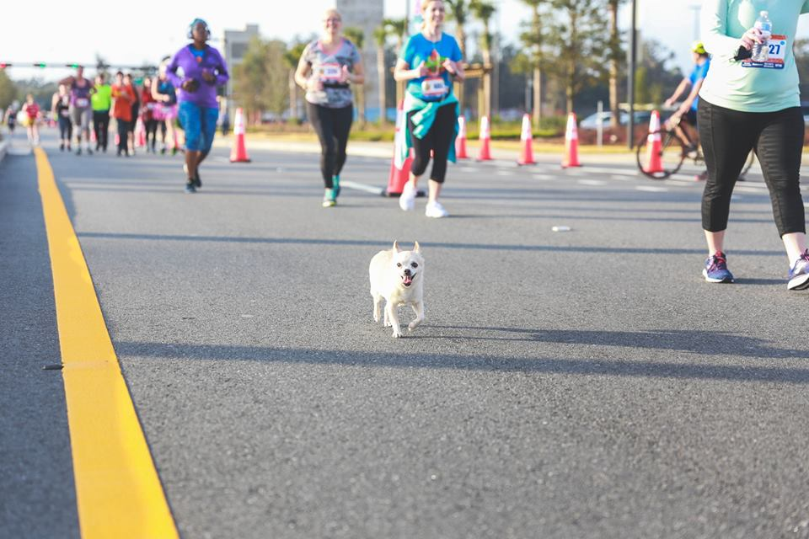 |  | Florida Track Club  - March Newsletter 2019!  - Issue Date
Club with the Orange on the singlet |  | CElebrating 50+ years as a Club!

5Points of Life Race Weekend: 5k, Half and Full Marathon and Relay

Presented by LifeSouth

2/16-2/17/19
https://runsignup.com/Race/Results/48052/?remMeAttempt=#resultSetId-144382;perpage:10

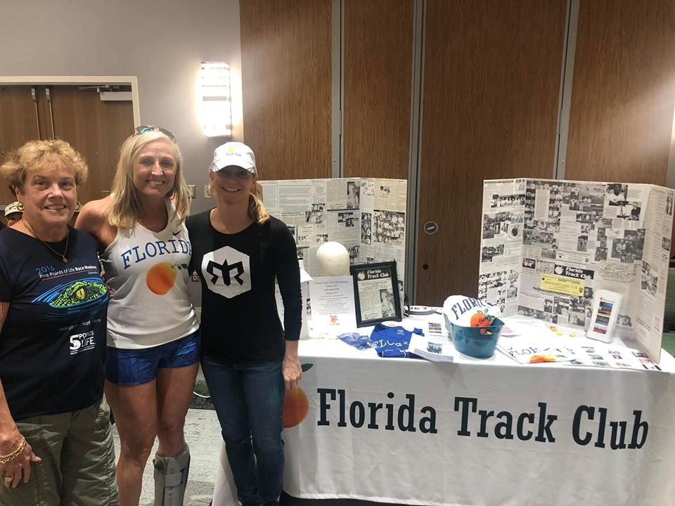
Gay Roberts, LaVonne Rembert, and Karen Harbaugh working the FTC table at the expo.

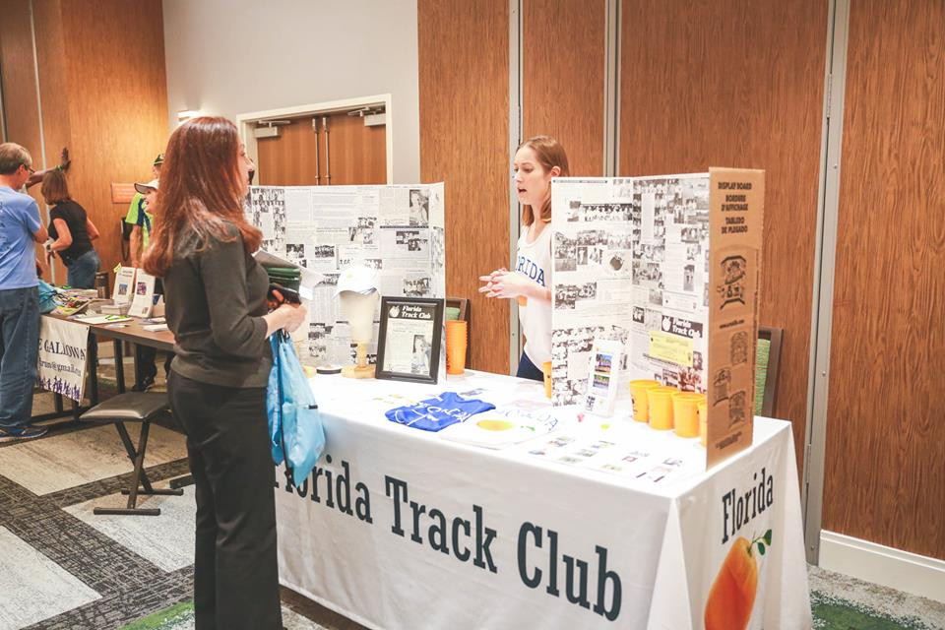Rae Powers at expo table.
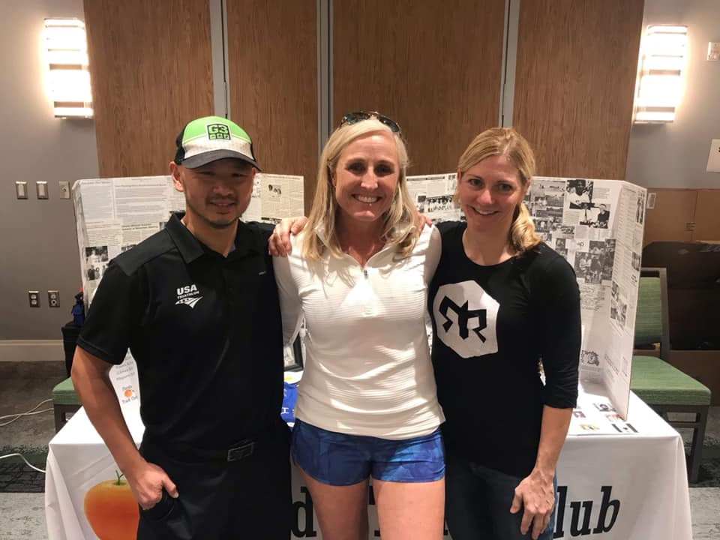
Tim Donovan, LaVonne, and Karen
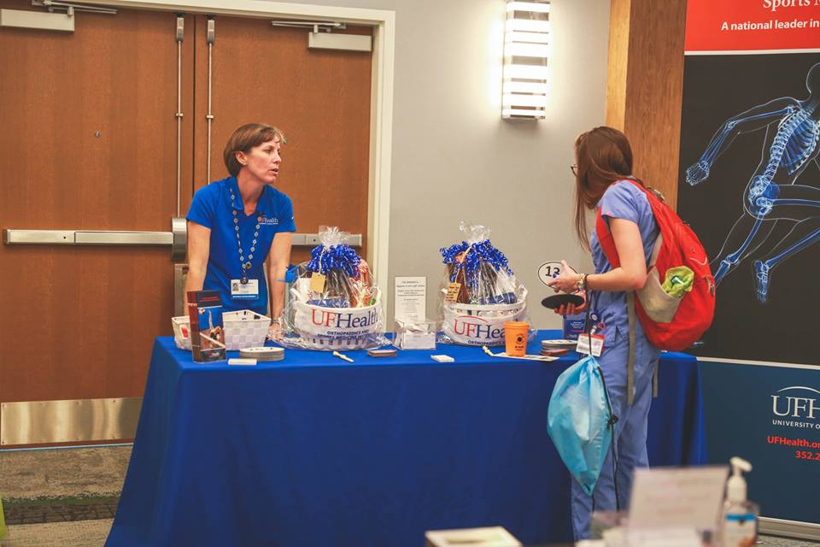
Our club sponsor, as well as a sponsor of the race weekend, Orthopedic Sports Medicine Institute (OSMI) at the race expo.
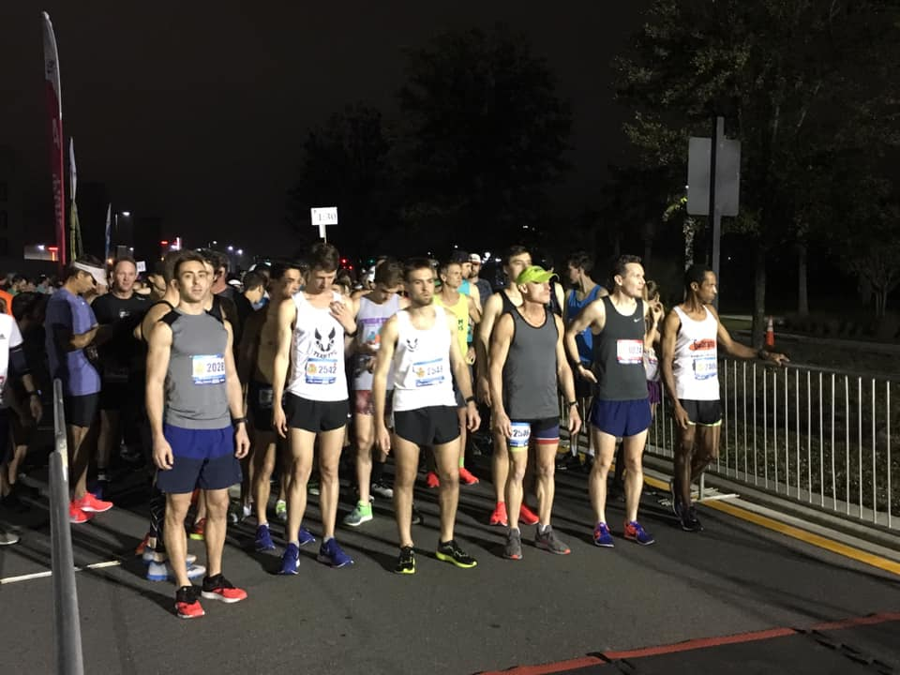
Start of the Half and Full Marathon

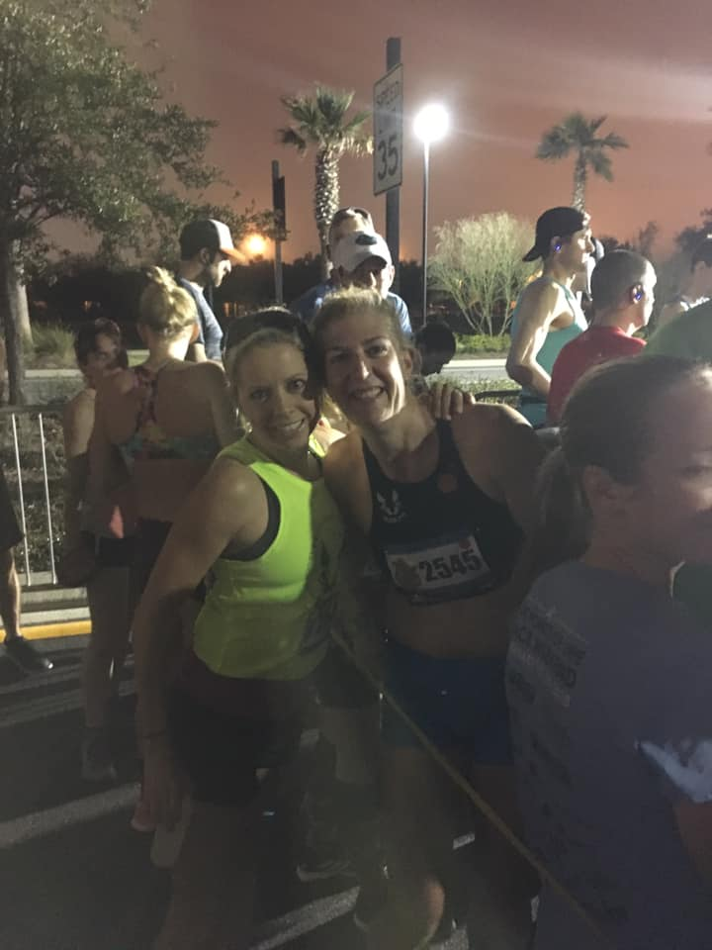
Mary Andrews and Gretchen Loyd prior to the start of the half-marathon.
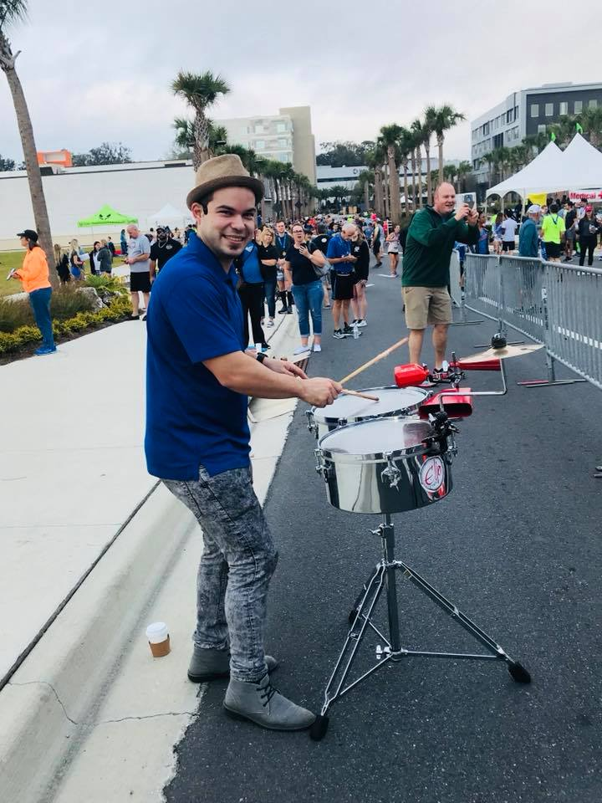
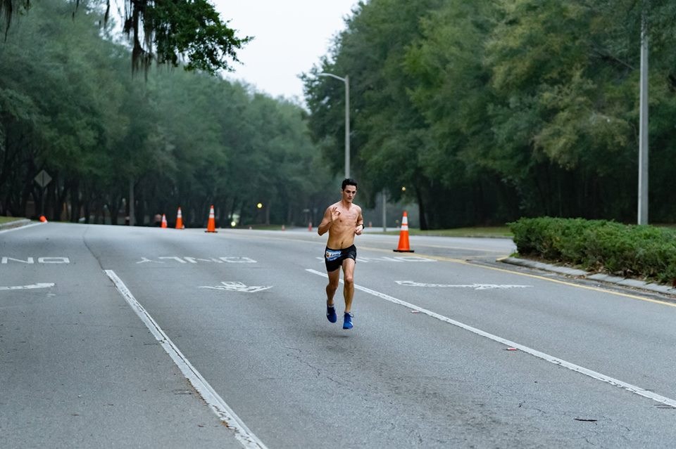
Hutson Rapier ran 1:21:20.6 and was 1st in the M35-39 age group.
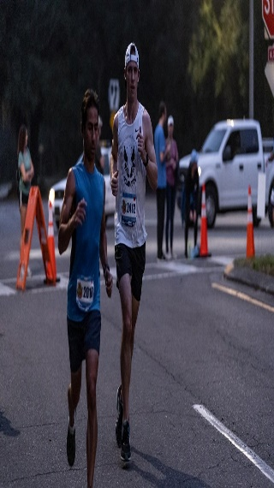
Justin Thompson ran 1:48:40
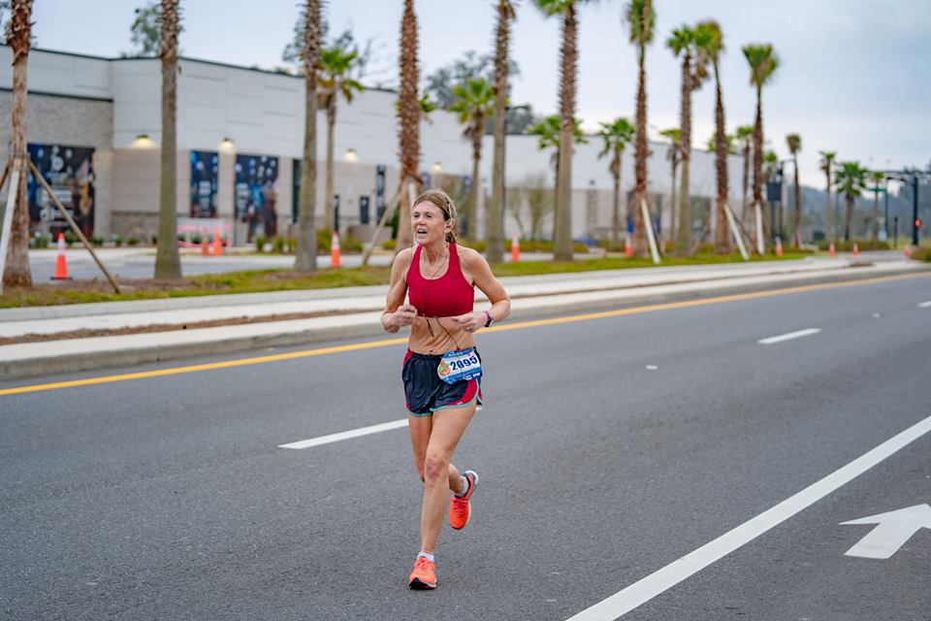
Elisabeth Diamond ran 1:50.55.9 and placed 2nd in F55-59 age group.
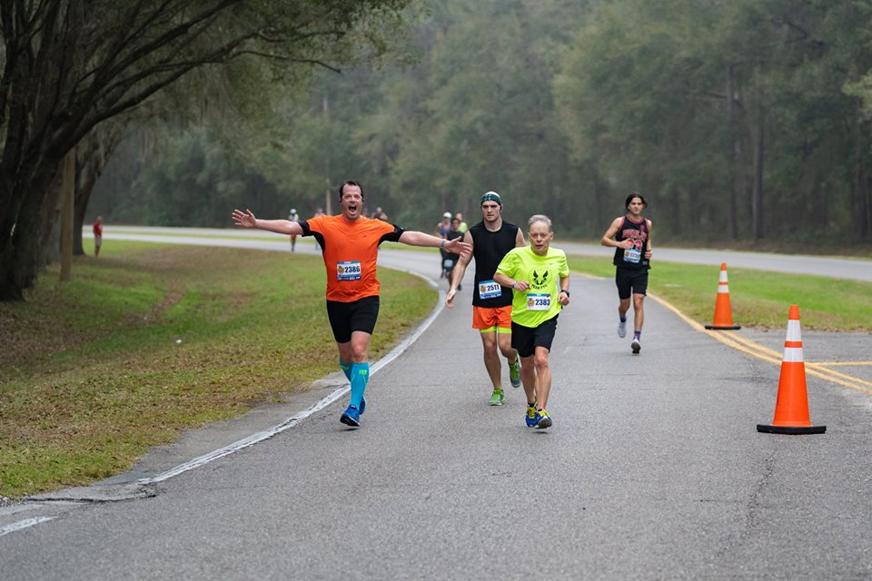
Doug Waldo ran 2:07:58 and was 2nd in M65-69 age group.
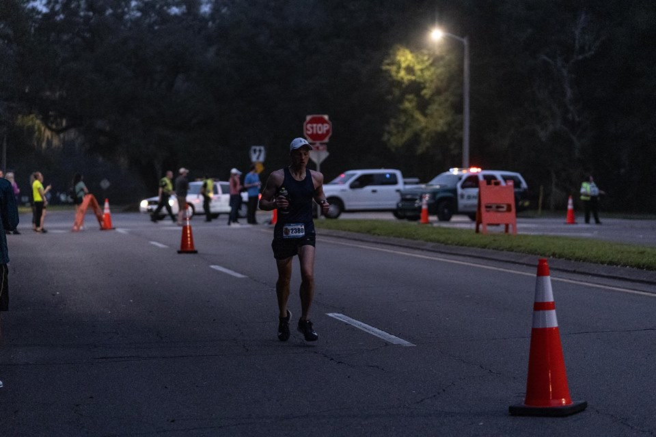
Stacy Voils ran 1:33:53.9 and placed 3rd in the M45-49 age group.
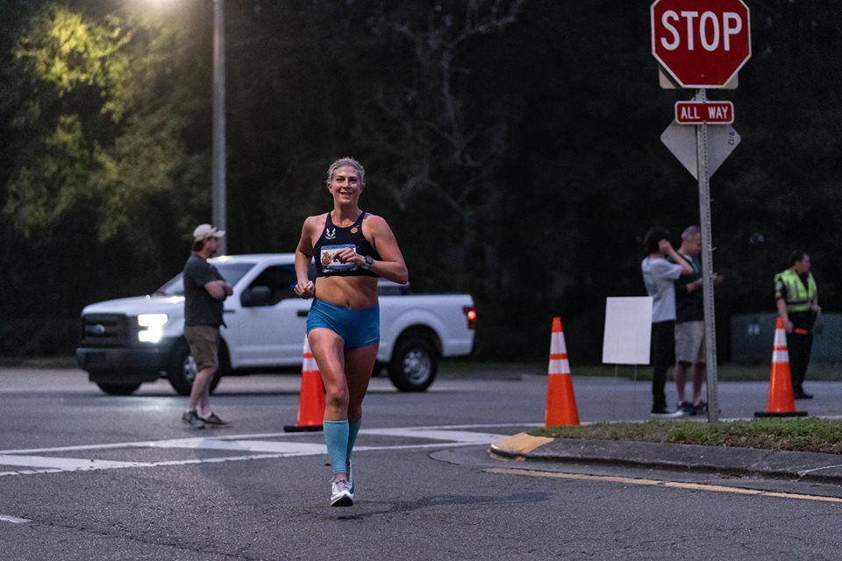
Gretchen Loyd ran 1:37.23.9 and was the Master’s Winner.
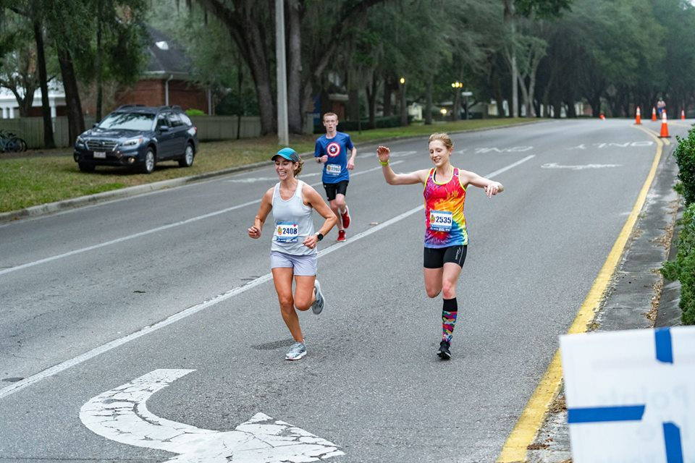
Lisa Johnson and Meredith DeFranco both ran 1:32:09 for 1st and 2nd place women.
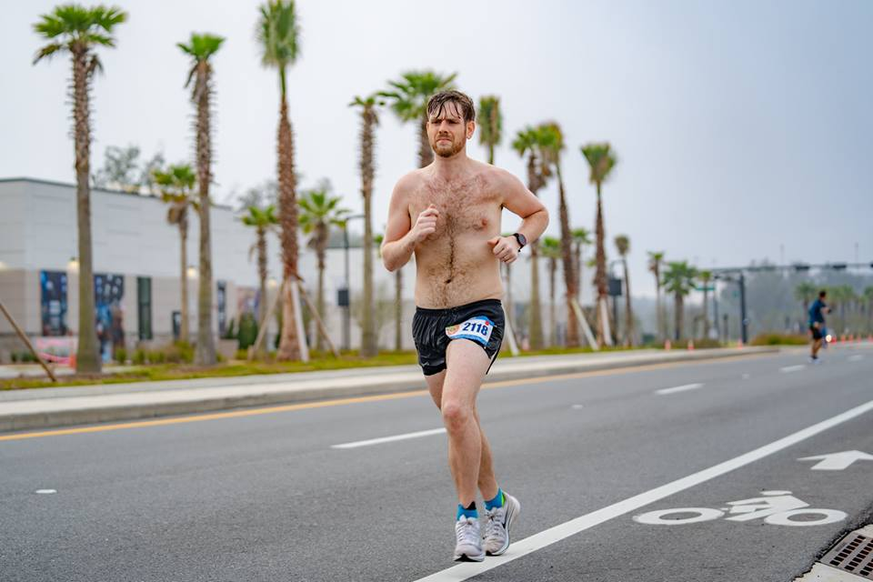
Trey Fields ran 1:43.50.9 and placed 5th in M25-29 age group.
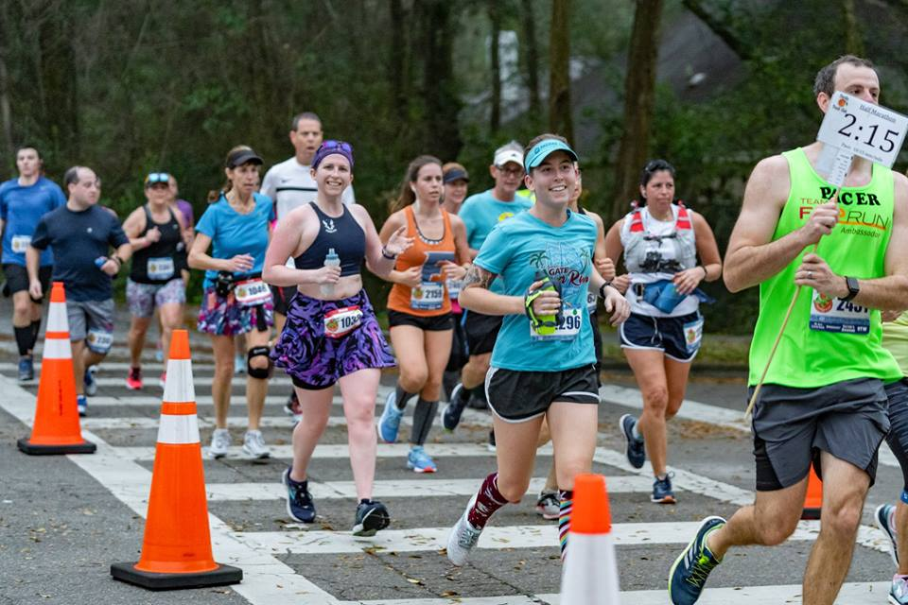
Board member Nic Armfield paced the 2:15 half-marathon group.
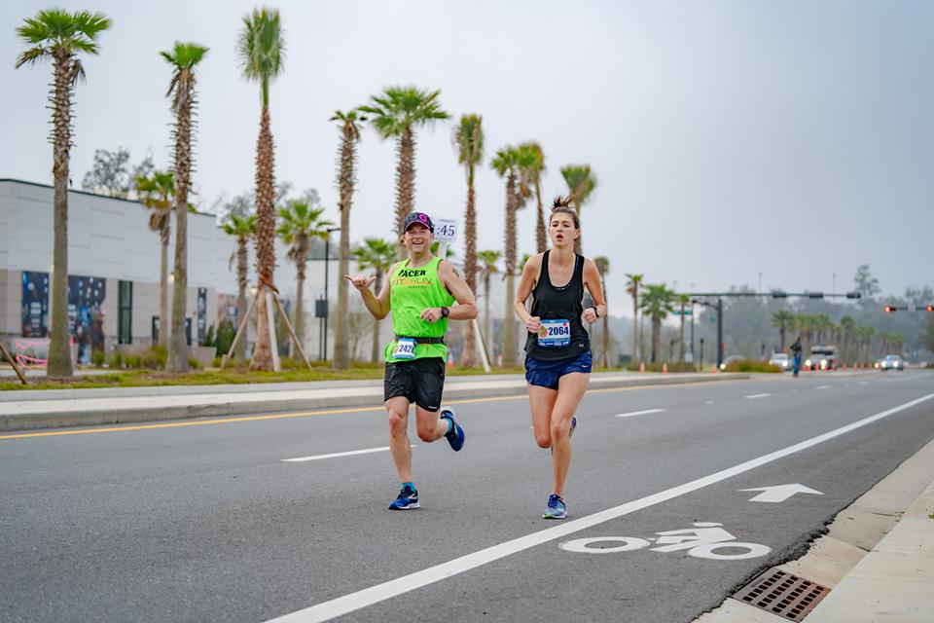
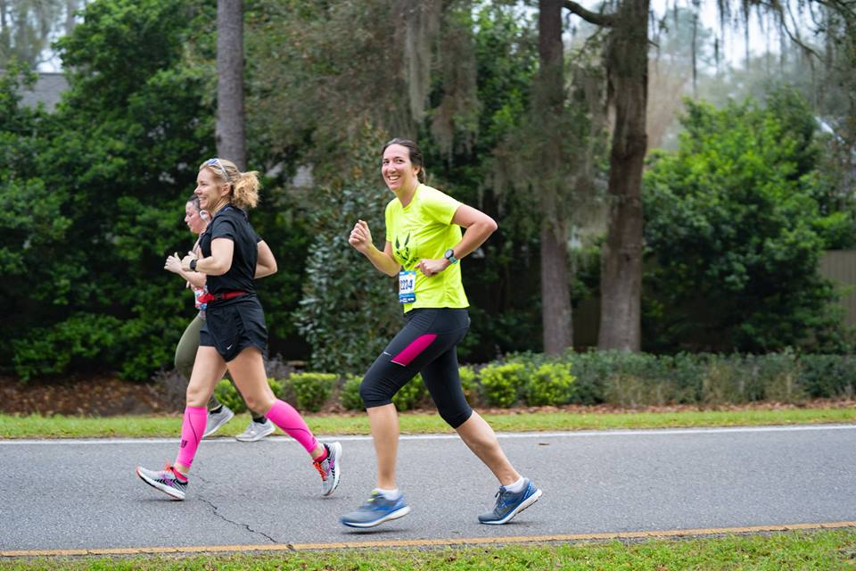
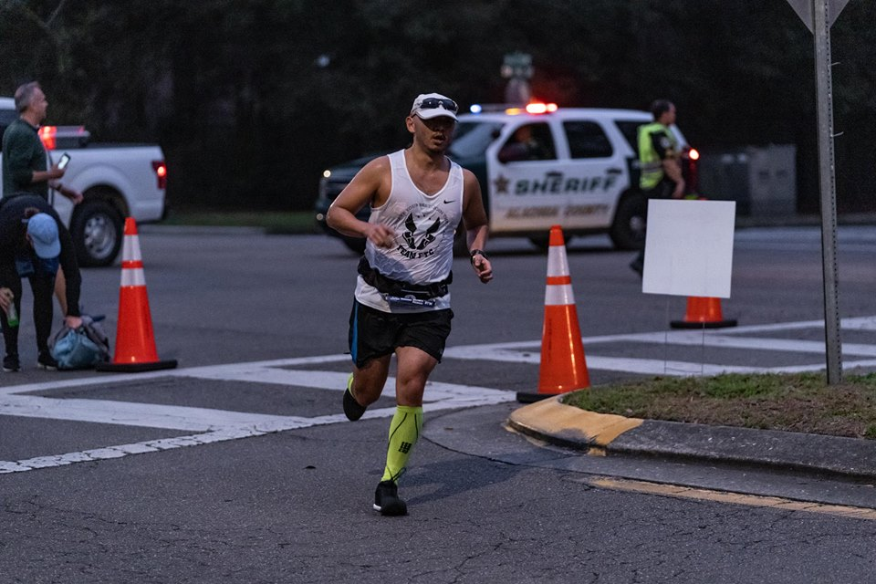
Tim Donovan ran 1:39:00.8 and placed 1st in the M40-44 age group.
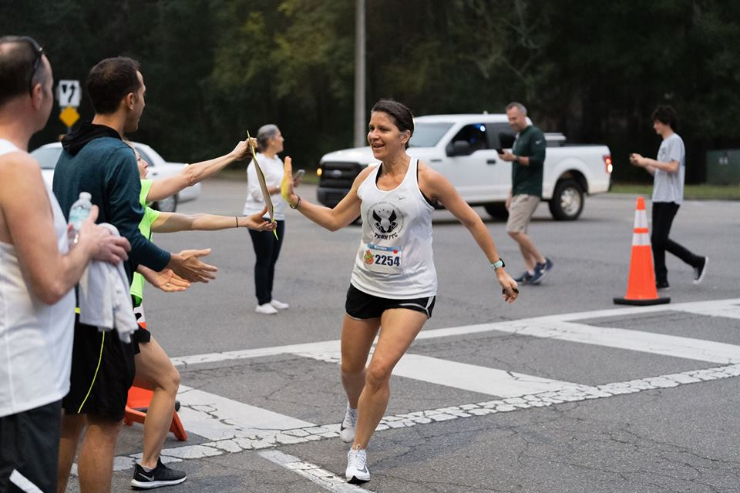
Victoria Pagan-Wolpert ran 1:53:19.8 and placed 1st in the F50-54 age group.
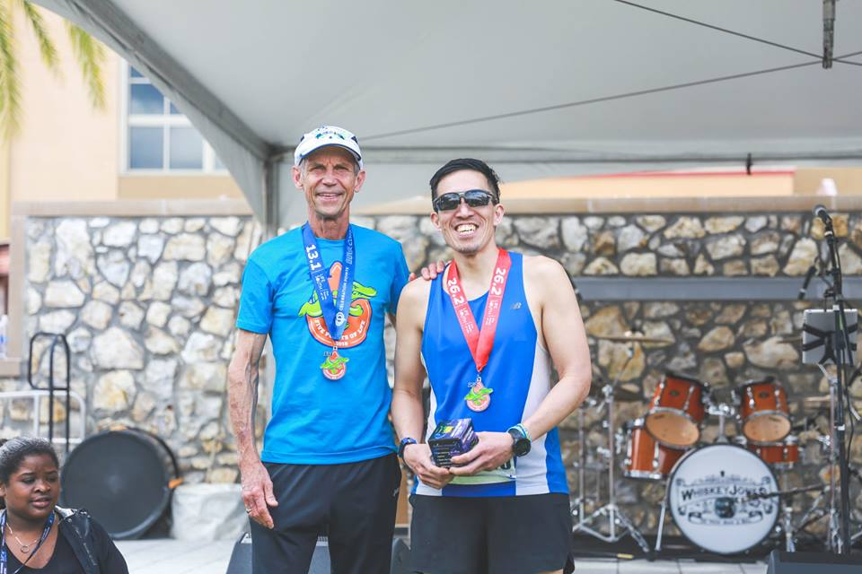
Mark Ou ran 4:13:53.8 in the marathon and finished 2nd in the M45-49 age group.
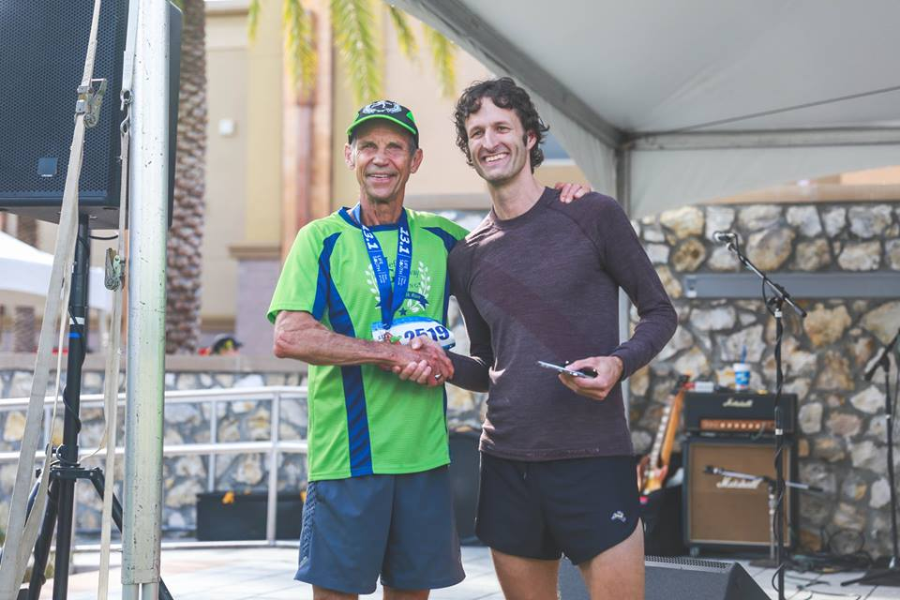
Ben Wise ran 1:24:54.8 and won the Men’s Masters Division.
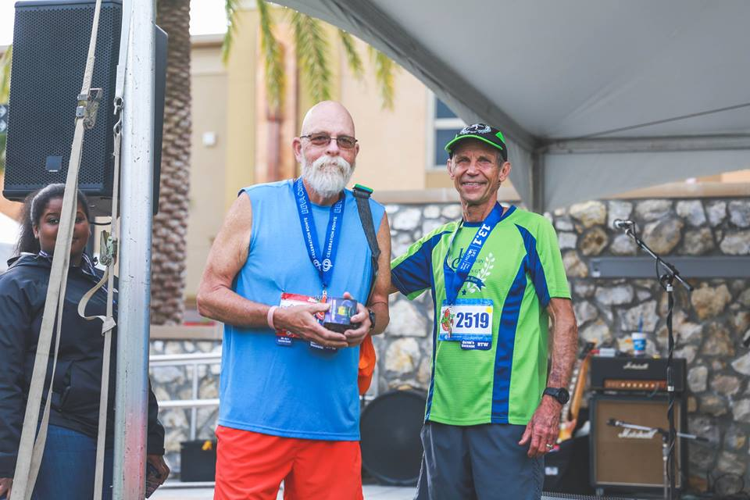
John Cartell ran 50:36 in the 5k and placed 6th in the M65-69 age group.
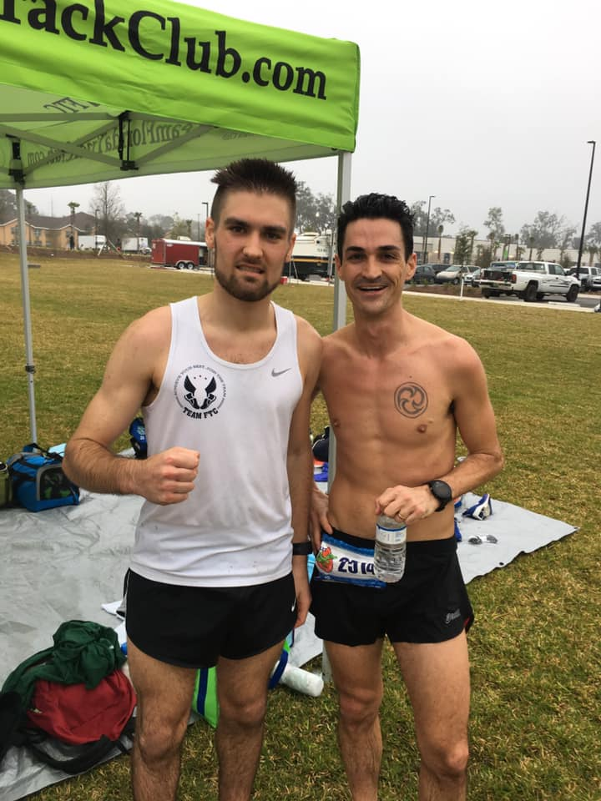
Calum McFetridge and Hutson Rapier. Calum won the half marathon in 1:11:43.4
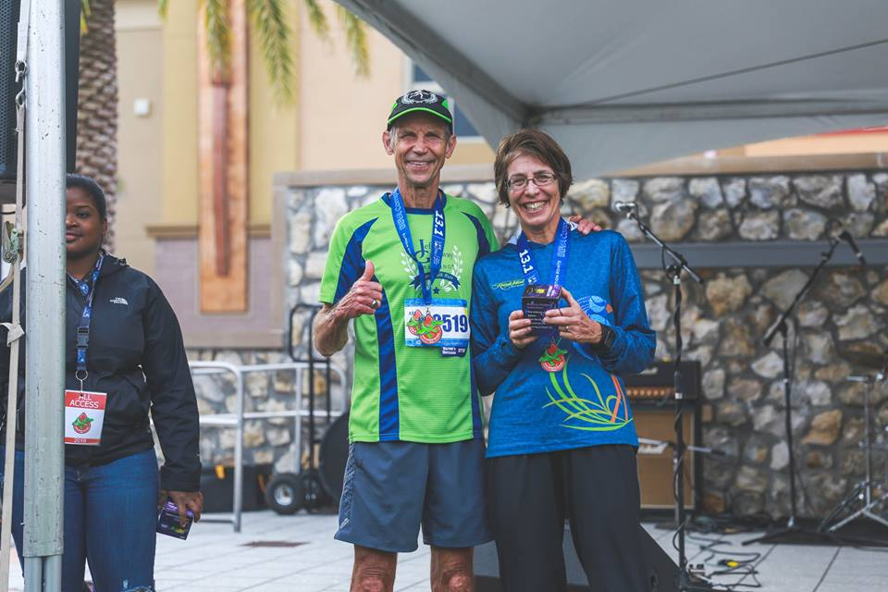
Diane Miller ran 2:03:23.8 and placed 2nd in the F65-69 age group.
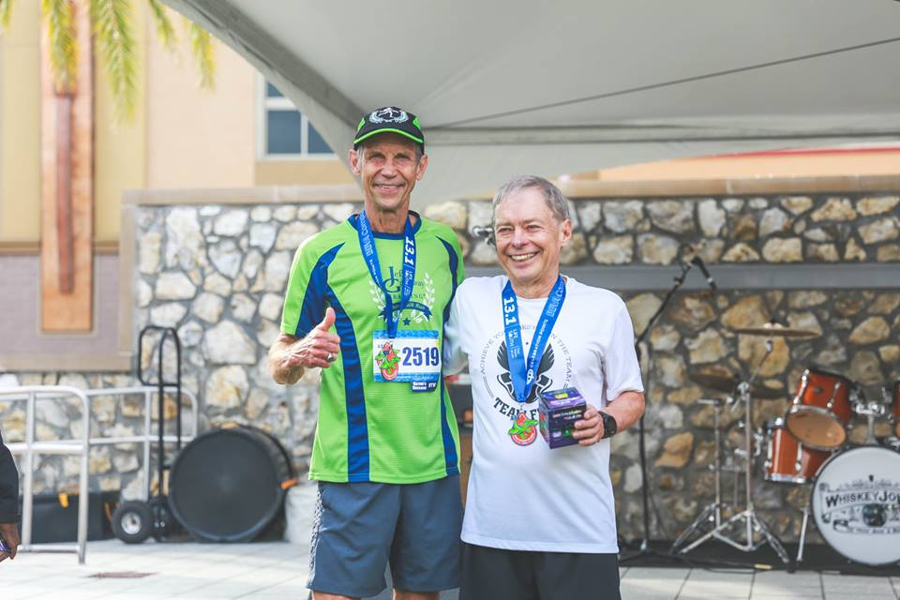
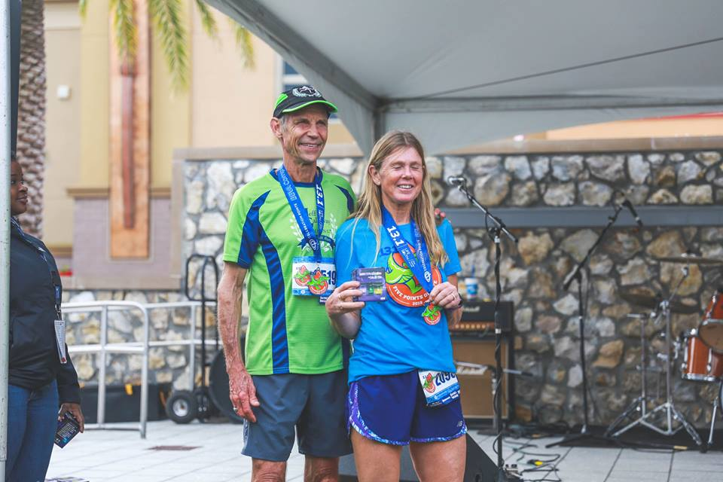
Elisabeth Diamond and Jeff Galloway.
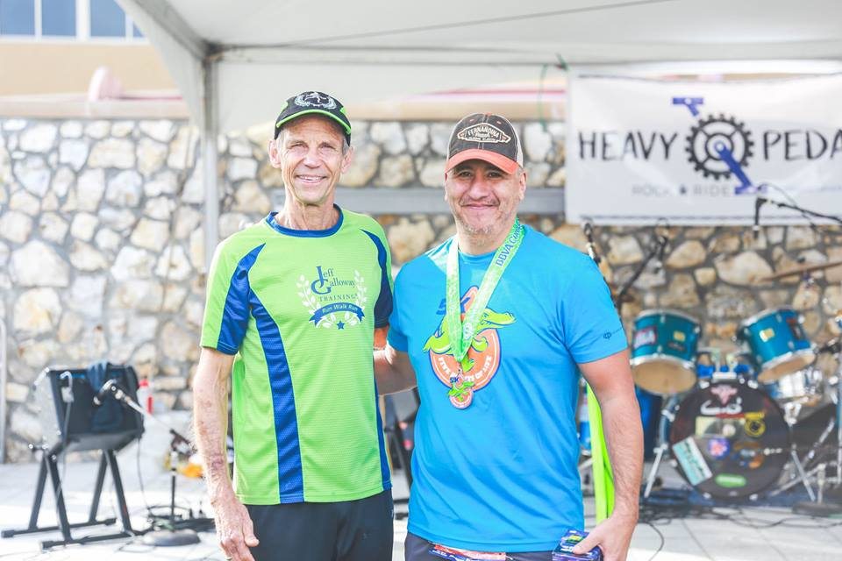
Eric Torres ran 22:05.6 and placed 1st in the M50-54 age group.
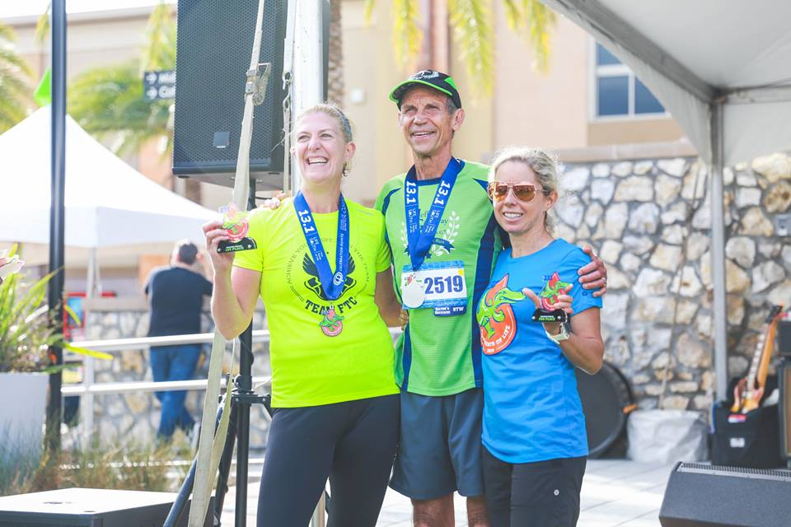
Gretchen Loyd and Mary Andrews with Jeff Galloway. Mary ran 1:41:36.0. She and Gretchen went 1-2 in the Women’s Masters Division.
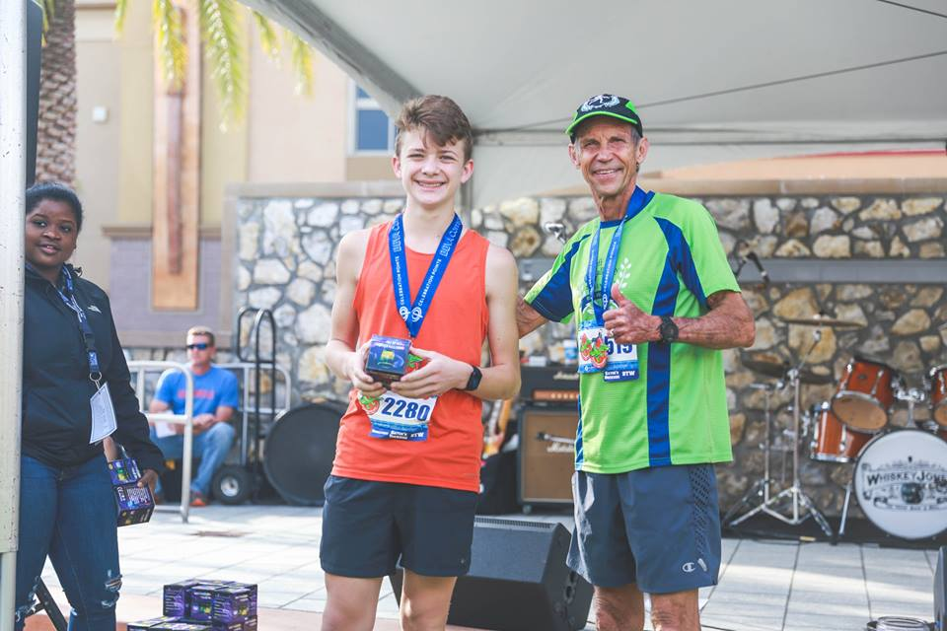
Ian Ragsdale ran 1:42:57 and finished 2nd in the M1-15 age group.
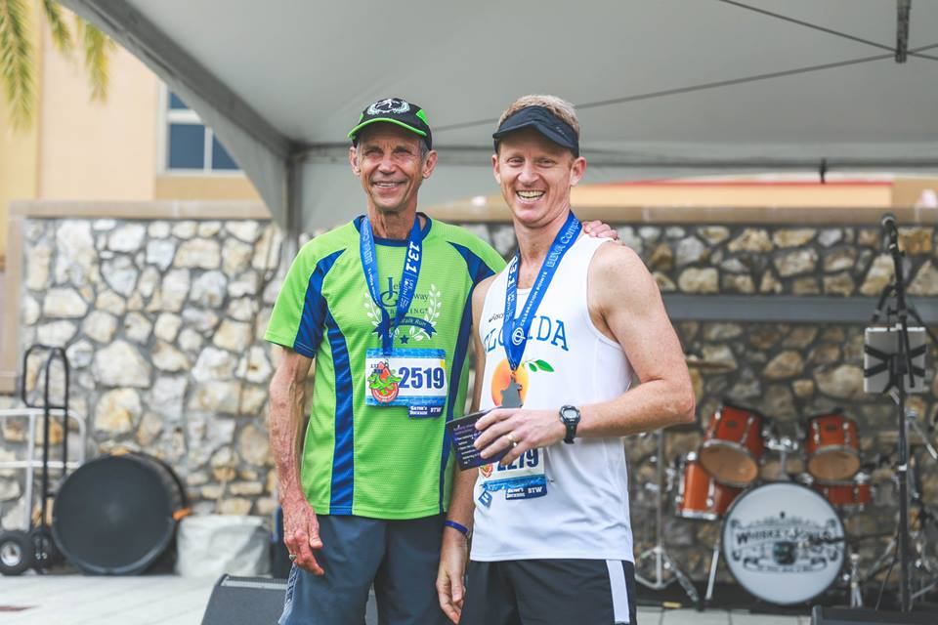
Board member Andrew Ragsdale ran 1:41:49.2 and placed 3rd in the M40-44 age group.
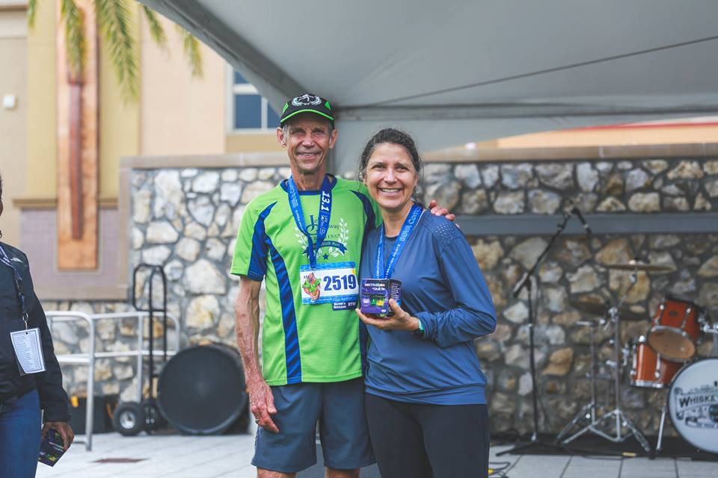
Victoria Pagan-Wolpert and Jeff Galloway.
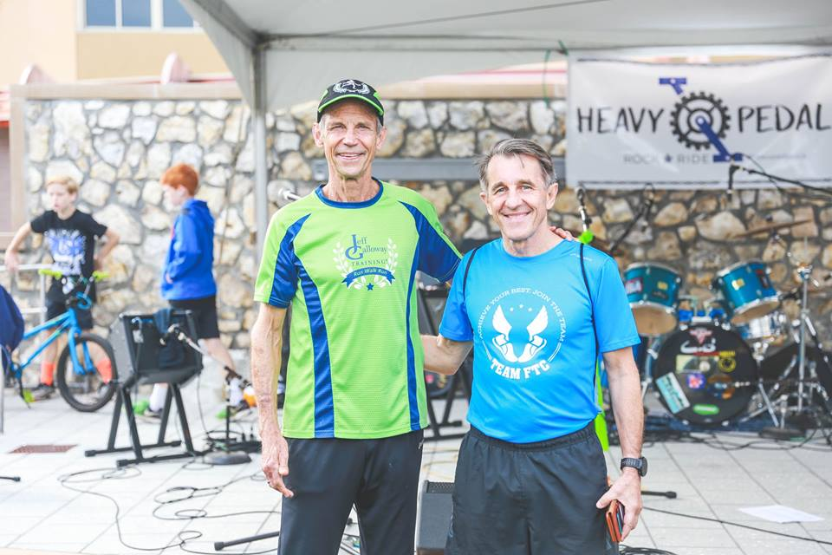
John Johnston ran 22:05.6 in the 5k and placed 1st in the M65-69 edition.
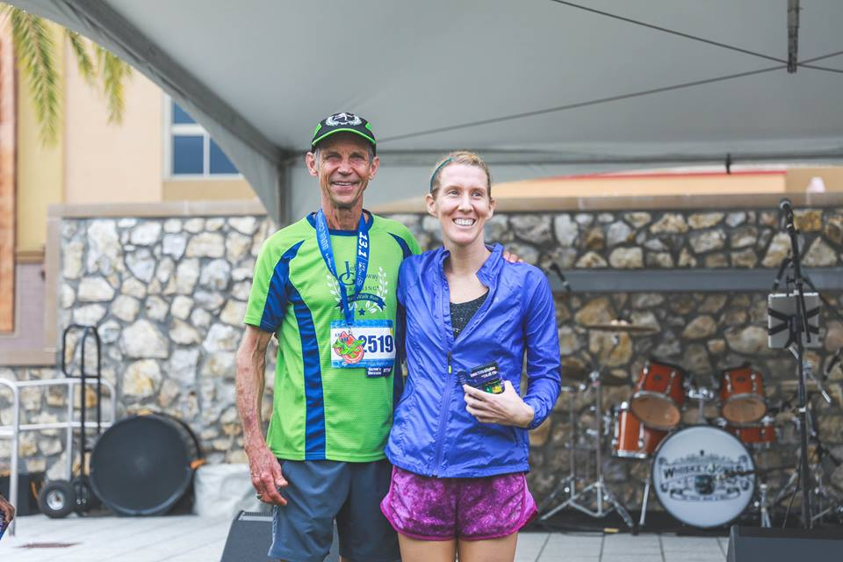
Lindsay Fields ran 1:41:54.4 and placed 1st in the F25-29 age group.
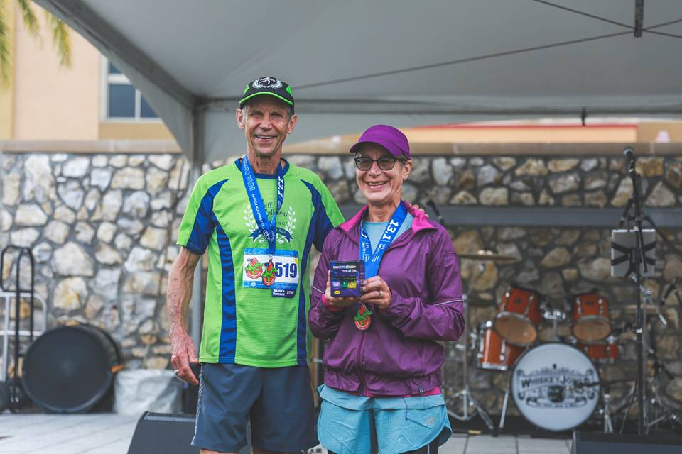
Loretta Engler ran 1:50:48.6 for 1st place in the F65-69 age group.
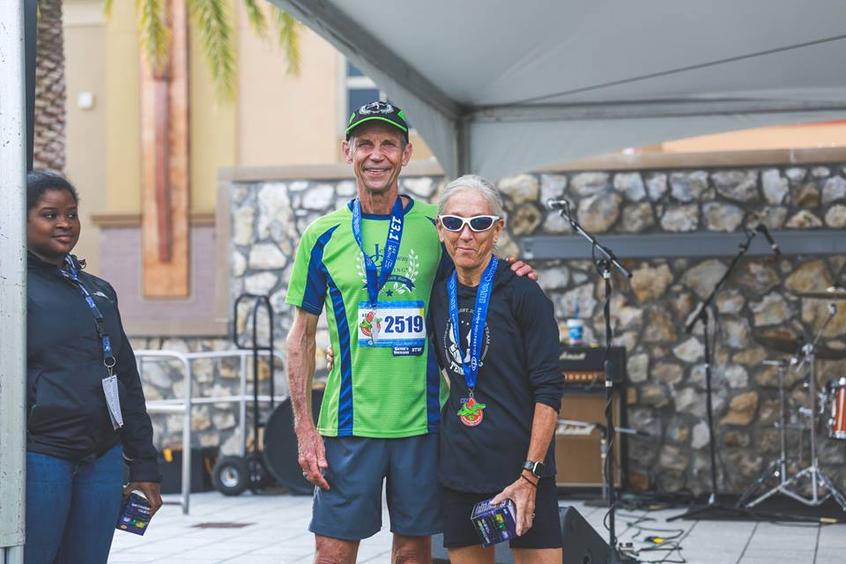
Lucy McCausland ran 1:43:55.1 and won the F60-64 age group.
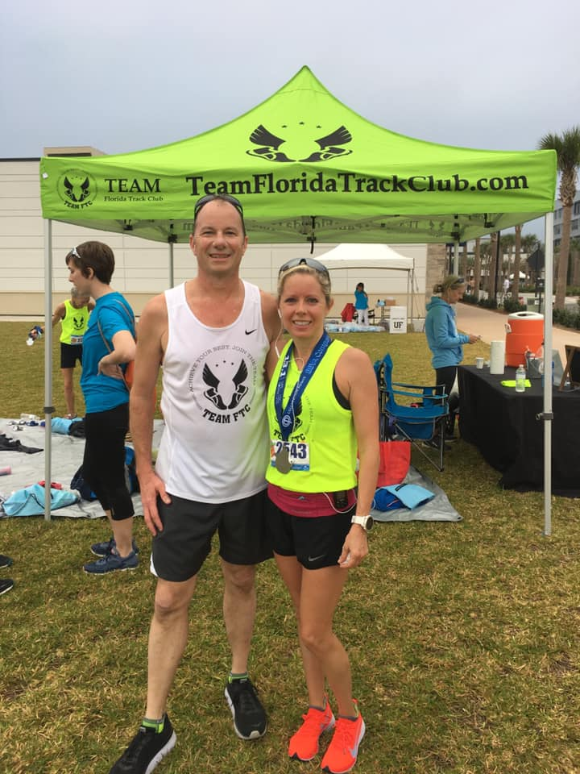
Michael Williamson and Mary Andrews.
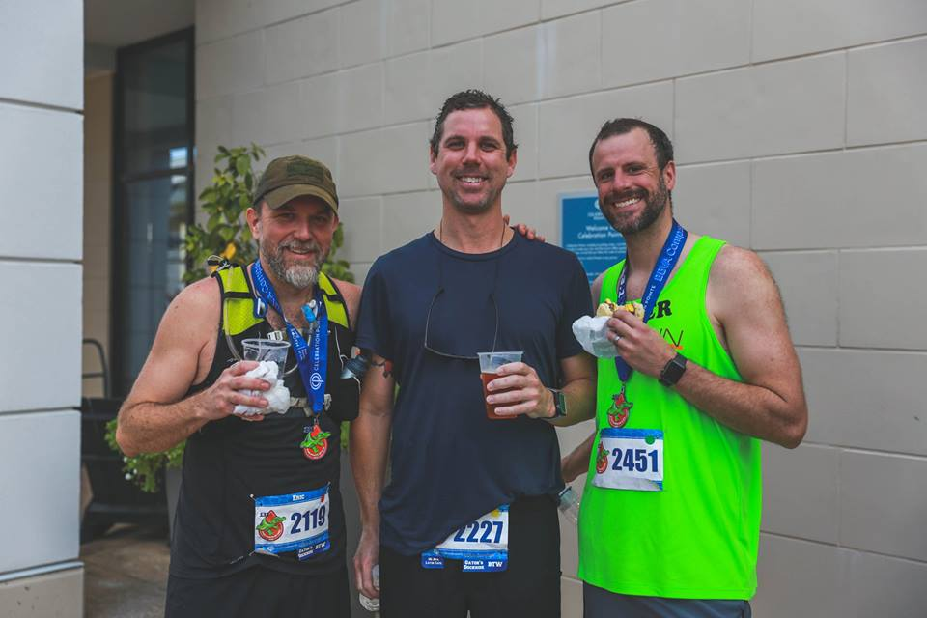
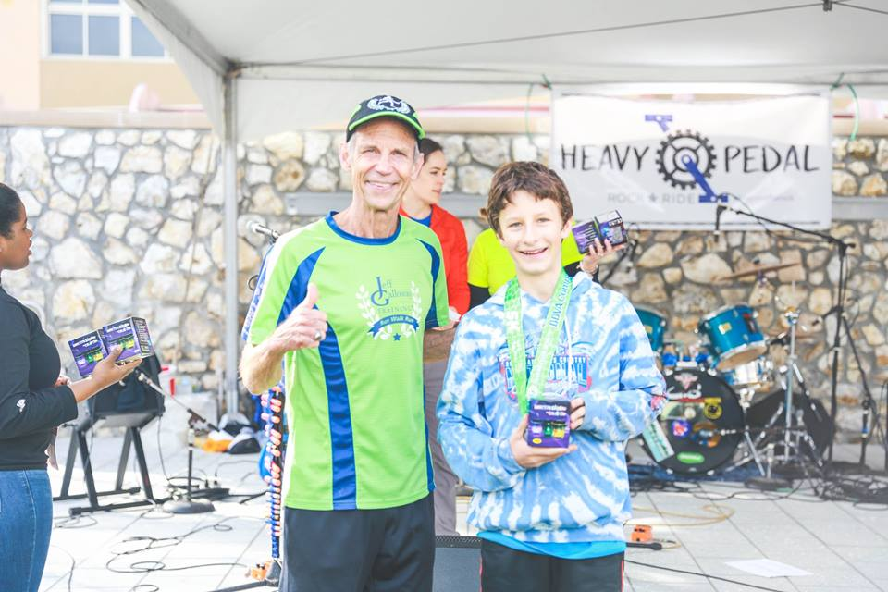
Philip Matchev and Jeff Galloway.
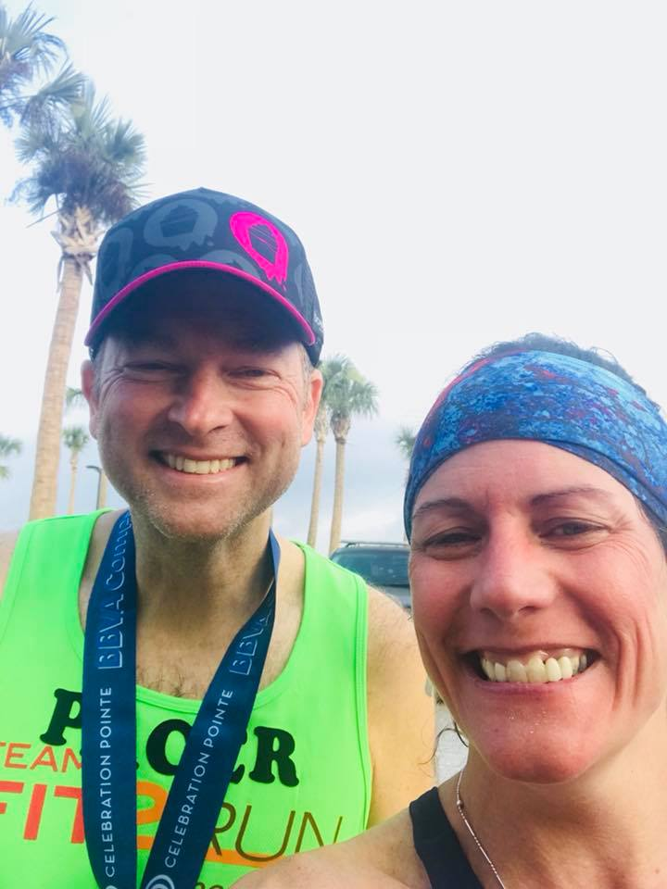
Board member and Pacer Soren Brockdorf and Angela DeSimone. Angela ran 1:44:00.0 for 1st place in the F45-49 age group.
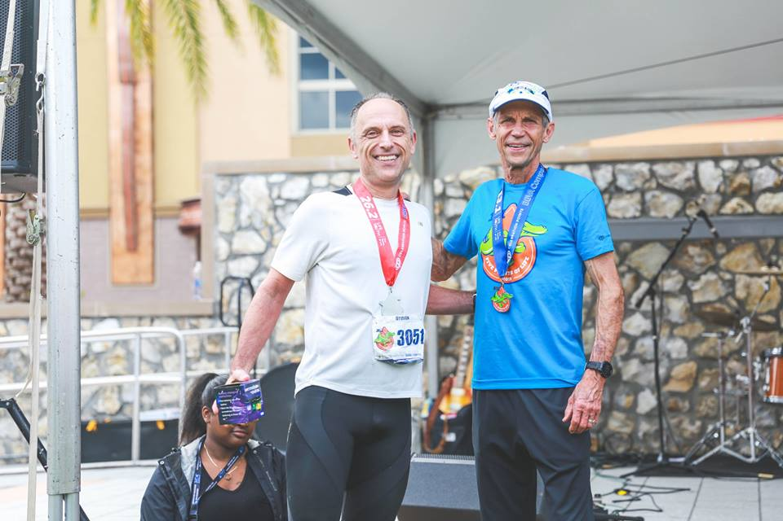
Steve Lachnidt ran 3:54:17 in the marathon for 2nd place in the M55-59 age group.
Other FTC finishers in the 5Points Races:
5K: Steve McCready (23:51), Katie Avery (25:44), Paul Hargrave (26:37), Robin Onufrock (30:34), Gordon Anderson (32:25), Jessica Garand (32:45), Ann Bussemi (37:20), Sue Wagner (41:50), Sarah Kotranza (50:26)
Half-marathon: John M. Sansalone (1:17:56), Matthew Bauer (1:18:03), Johnny Sansalone (1:34:07), Zac Radke (1:35:58), Darin Acosta (1:54:27), Vanessa Rapier (1:56:15), Emma Morey (1:57:05), Konstantin Matchev (1:57:06), Jake Thompson (2:00.05), Jill Ragsdale (2:00.34), Janis Acosta (2:06:12), Ozzy Vidal (2:07:02), Kathy Benton (2:23:18), Brook Armfield (2:27:38), Sarah Kotranza (2:27:52), Jeff and Barbara Galloway (2:37:06)
Congratulations!!!!!

Race Report: Donna Half Marathon 2019
Catherine Martin
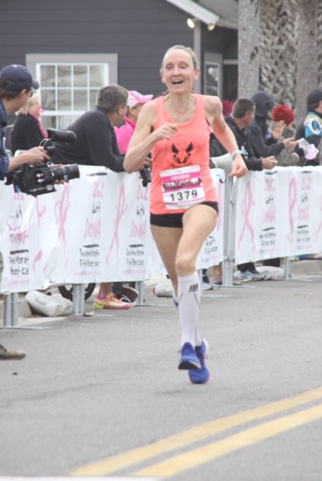
A couple of weeks ago I participated in the DONNA Breast Cancer Marathon for the 5th year in a row and had a blast. In the past I ran the full marathon. This year I chose to do the half since I am getting ready for Boston in a few weeks.
I am a two-time breast cancer survivor and this race means so much to me. Every time I cross that finish line I get very emotional and am so grateful for still being around and being able to do the things I love.
This year presented a totally new course, which is beautiful, fast and flat and that takes you through beautiful beach communities with scenic views and amazing crowd support. At mile 5 I experienced the highlight of my running career when I suddenly found myself running next to running legend Joan Benoit Samuelson, 1986 Olympic Marathon Gold Medalist. We actually ran next to each other and talked about my beautiful home country Austria for a few minutes until she finally took off. This was so cool and she was so nice!
At mile 9 I got another surprise when three of my dear friends from TeamFTC showed up with the sweetest homemade support poster to cheer me on. I had no idea they would be there and it was so great to see them and gave me an enormous energy boost.
I have been in remission for 3 years now and finally feel my former strength coming back. When I was going through treatment, there were days when running just 1 mile was a challenge for my severely beaten body. Being able to recover from all of this and reaching my goal of 1:33 at the DONNA (my 3rd best ever half-marathon time!) showed me that there is no obstacle too big, that it can’t be overcome as long as you set your mind to it and believe that anything is possible.
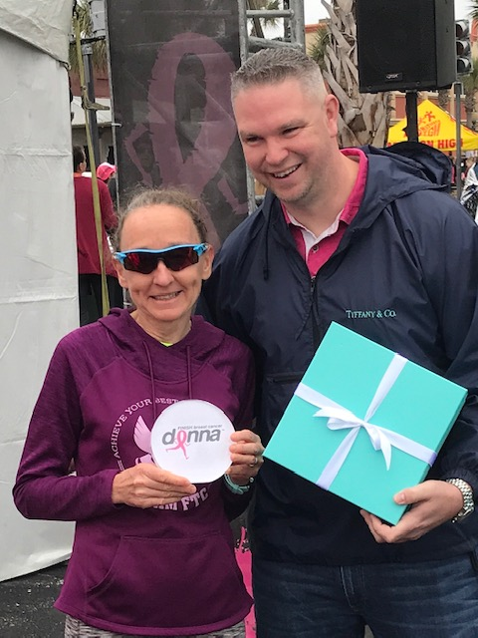

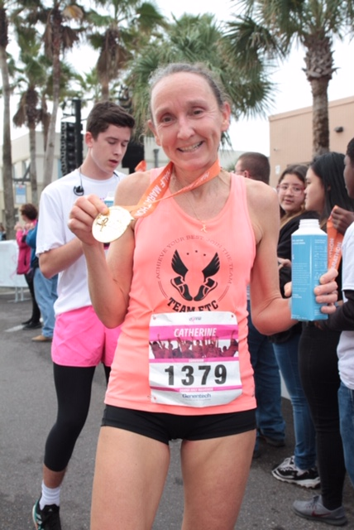
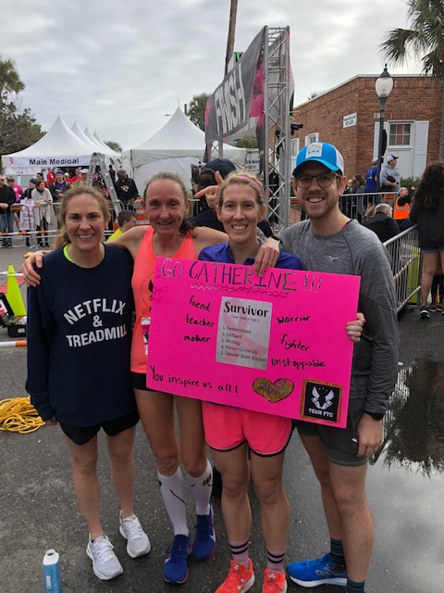

Upcoming March and April Races in and around Gainesville
March
3/2 Race the Tortoise 5K
The House Next Door 5k, Deland
Lakeland Regional Health Promise Run (10K and 5K), Lakeland
Donna 5k, Ponte Vedra Beach
Lighthouse Run 5k, St. Augustine
3/9 Gate River Run 15k, Jacksonville
Joey’s Wings 5k and Fun Run
3/17 St. Paddy’s Day Run, Jacksonville
3/23 Trail of Payne 10k
Hearoes for Hearing 5k
Srping 4 a Cause 5k, St. Augustine
3/24 Trigators Supersprint Triathlon
3/28-3/30 Pepsi Florida Relays
3/30 Chik-Fil-A Chicken Biscuit Run 5k, Jacksonville
April
4/7 Apryle Showers 10k Run, Ponte Vedra
4/10 LGAA Charity 5k XC Challenge
4/27 Run the Good Race 5k
Baby Gator Spring 5k
U Run U Pick 5k Blueberry 5k, Clermont
February Meeting Recap:
Danielle Gertner of Gernter Grind
2/4 @ 7PM
Orthopedic Sports Medicine Institute (OSMI)
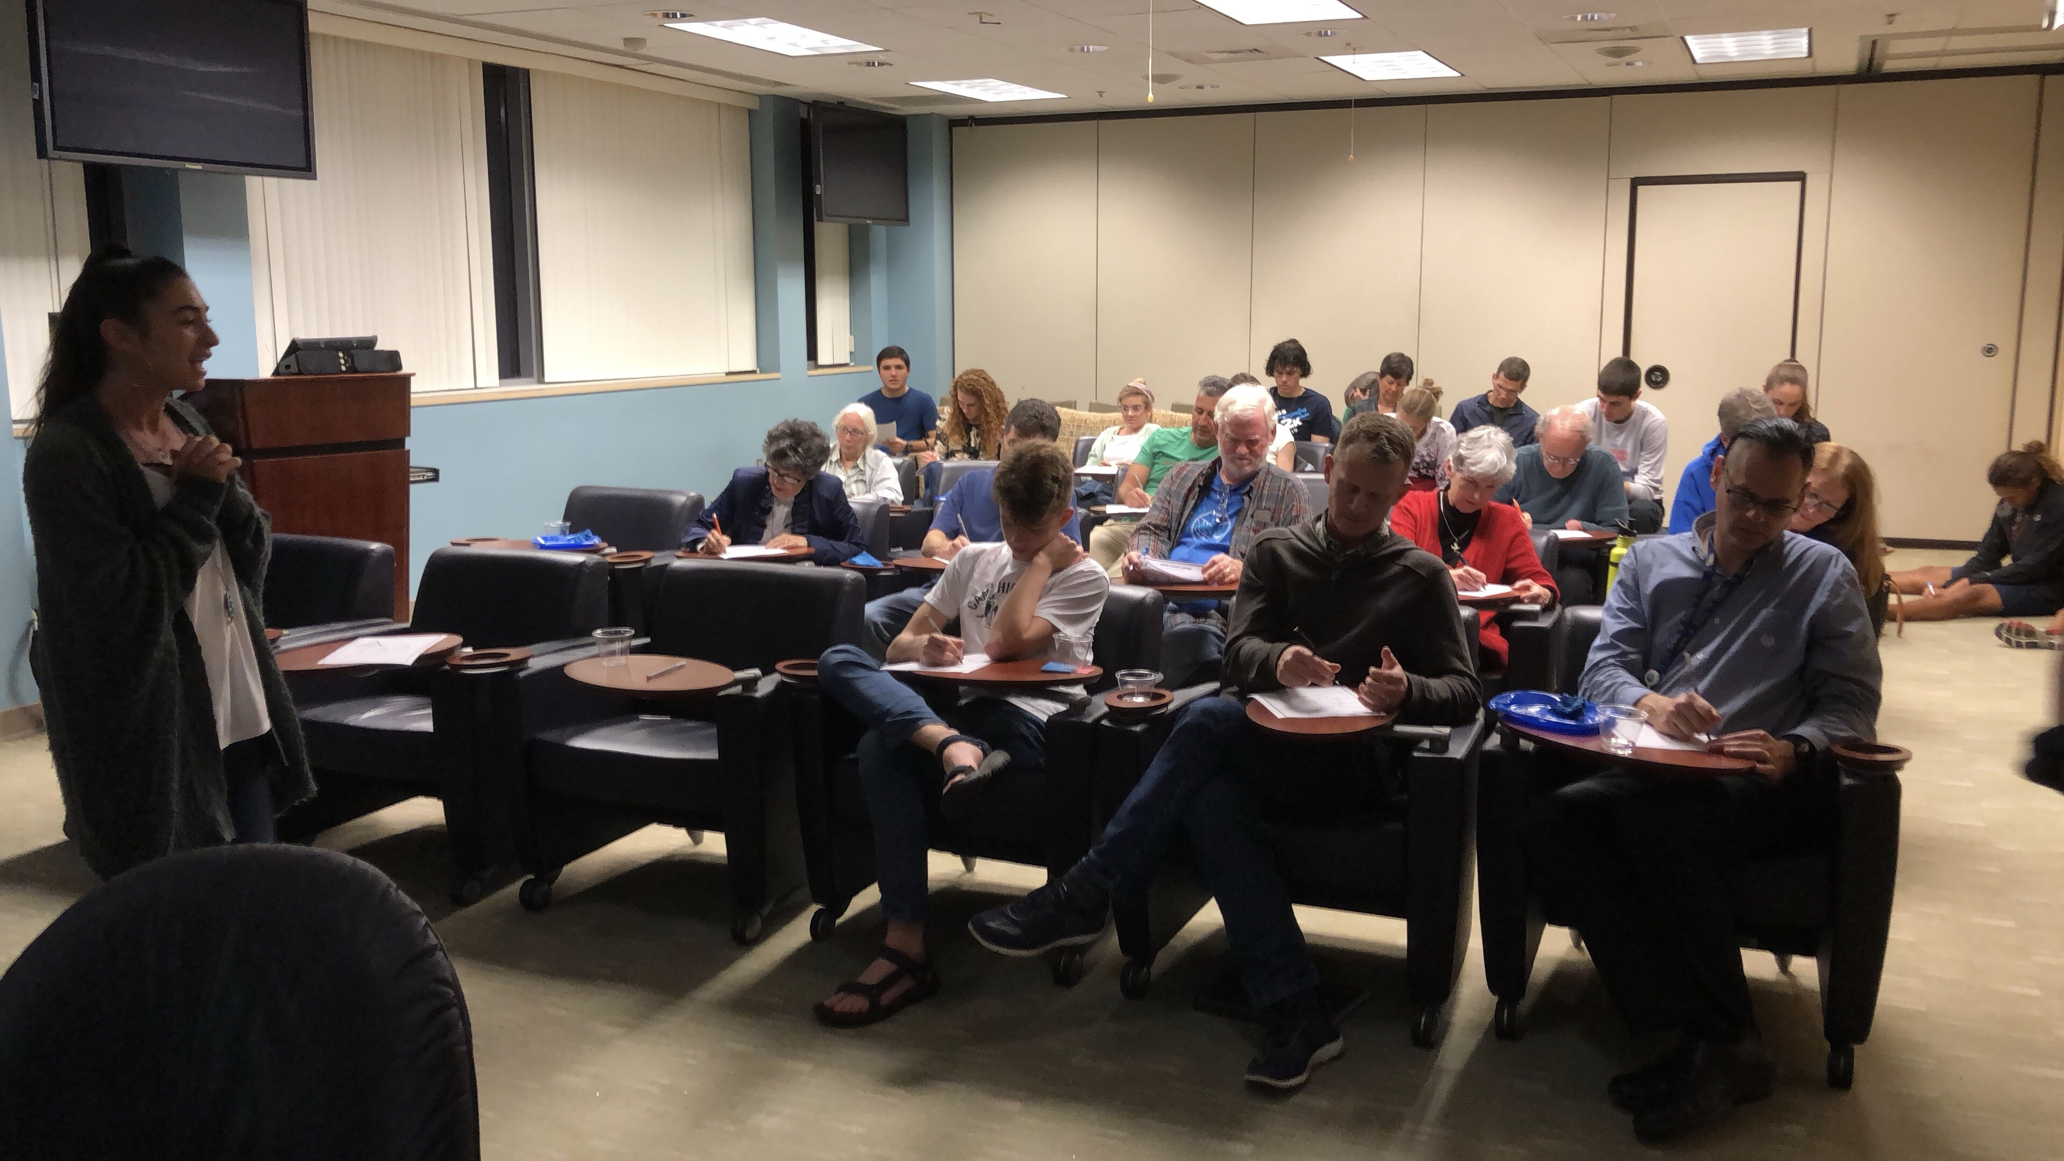
Thank you to Danielle Gertner of Gertner Grind for coming and speaking to the club about finding our why and releasing roadblocks in our lives to achieve our dreams. Remember to fill out those worksheets and send them to her at gertnergrind@gmail.com for a free one hour coaching session!
Below is the poem with which she began her fantastic talk.
The Man in the Glass

Peter Dale Wimbrow Sr.

When you get what you want in your struggle for self
And the world makes you king for a day
Just go to the mirror and look at yourself
And see what that man has to say.
For it isn’t your father, or mother, or wife
Whose judgment upon you must pass
The fellow whose verdict counts most in your life
Is the one staring back from the glass.
He’s the fellow to please – never mind all the rest
For he’s with you, clear to the end
And you’ve passed your most difficult, dangerous test
If the man in the glass is your friend.
You may fool the whole world down the pathway of years
And get pats on the back as you pass
But your final reward will be heartache and tears
If you’ve cheated the man in the glass.

March Meeting:
Eduardo Garcia!
Monday, March 11th 7 PM
Read more below about our special March guest speaker.

High School Dreamer to Olympic Qualifier: Garcia's Journey
3061
Adair Lyden
Editor Florida MileSplit (previously published on fl.milesplit.com)
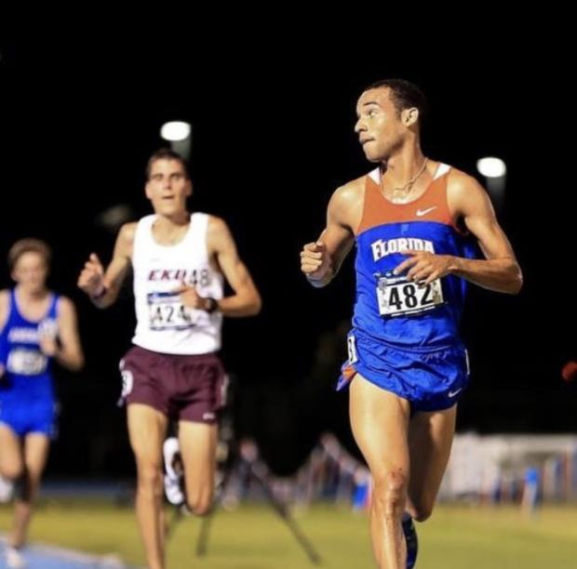
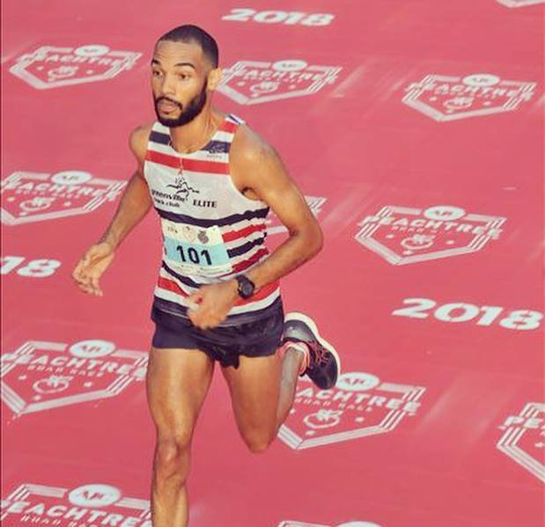
Big news coming out of the Jacksonville area.
Mandarin HS and University of Florida alumnus, Eduardo "Eddie" Garcia, raced his way to the Olympic qualifying standard for the Virgin Islands in the marathon at the Houston Marathon on Sunday.

The Journey Makes The Destination Worth It
Garcia, who trains out of Greenville SC with Asics Greenville Track Club Elite, ran a time of 2:18.50 for the 26.2 miles.
The Mandarin alumnus was a multi-time state medalist in the 1600m, 3200m, and 5000m, and while he was close to a state championship win in high school, Garcia's 4:16.65, 9:26.80, and 15:16 high school PR's fell short of the coveted state title. That did not stop Garcia from pursuing something far greater.
After graduating from Mandarin, Garcia went on to be a Florida Gator and join their top-notch distance program along big high school names like Mark Parrish, Jimmy Clark, and JL Hines to name a few.
Year after year, Garcia trained hard and fought for greatness. In 2015, the Gator became the 10,000m SEC Outdoor Champion in a time of 29:48 and he followed that performance up with a 14:36.76 in the 5000m.
After graduating UF, Garcia started his journey with Gainesville's own Florida Track Club, racing and winning local races as well as traveling internationally, representing the Virgin Islands.
In April of 2018, Garcia signed a two-year training contract with Asics Greenville Track Club Elite in Greenville, SC. After a few months of training under his belt, Garcia ran away with a 25th place finish at the 2018 USATF 10k Championships and a new half-marathon PR of 1:05.37 in Richmond, VA and now, an Olympic qualifying performance.
"Being able to represent the Virgin Islands on the international level is a huge honor for me. My father is from the island of St. Croix, so being able to put on the jersey where he was born is a really special feeling for me," Garcia said.

The Road Ahead
Garcia will represent the U.S. Virgin Islands at the 2019 World Championships, Pan American Games in Lima, Peru and the 2020 Tokyo Olympics.
Up next for the Florida native will be a few trips back home, including one to race the Gate River Run in March as well as to speak to the Florida Track Club at their March meeting on his journey to success.
For Garcia, these accomplishments have been fostered dreams since his time at Mandarin, nearly eight years ago.
"I would tell my younger self to have fun with the journey, embrace all of the friendships and experiences along the way," Garcia said. "Go back to the basics and let things come naturally."
****************
Come early for a good seat and for refreshments. Prior to the general meeting at 7PM, the FTC Board of Directors meets to discuss and vote on club business. For more information, email thefloridatrackclub@gmail.com.

Ride the bus to Gate River Run – FREE! (spots are limited!)

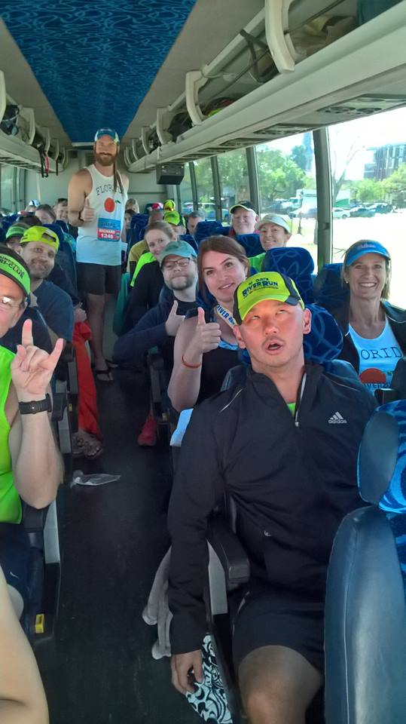

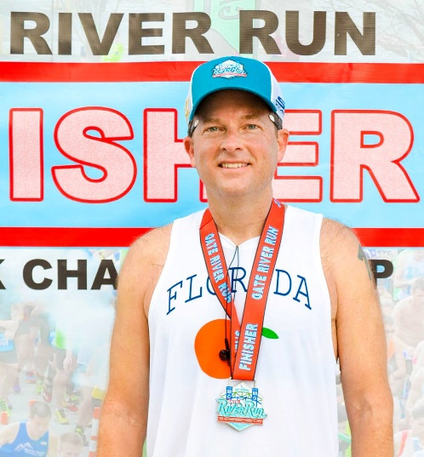
Reserve your seat today!
https://www.signupgenius.com/go/70a0549acab2fa0fd0-florida
Email Betsy Suda at thefloridatrackclub@gmail.com if you need an FTC singlet for Gate! We will also have singlets, hats, and visors for sale ($25 for singlets and $20 for hats and visors) at the 5POL Race Weekend Expo on Friday, February 15th (3PM-6PM) and Saturday, the 16th (9AM-4PM)

Thank you Volunteers!
Thank you to the following members who volunteered at the 5Points of Life Expo on behalf of the Florida Track Club:
John Casmus
Doug Waldo
Michael Rosato
Donita Higgins
Bruce Higgins
George Blake
Susan Blake
Tim Donovan
Karen Harbaugh
Rae Powers
Gay Roberts
Stephanie McGrail
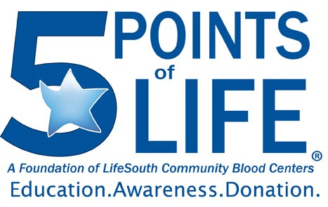
Thank you Pacers!
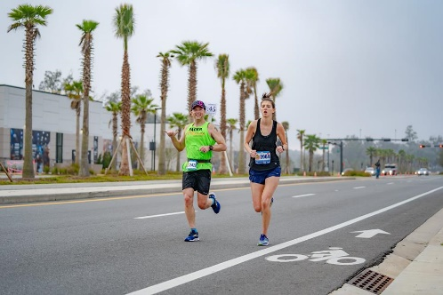
Trent Herzog
Hayden Pfefferkorn
Soren Brockdorf
Garret Claunch
Nic Armfeld
Carmen Brockdorf
Mahmoud Khelah
Natalie Carpenter
Elizabeth Hanselman
Frank Orlando
Alisa Thomas
Carolyn Ringerberg
Gurmit Singh Arora
Mary Ellen Thompson
Anand Patil
Rick Cubbedge

Running Group Opportunities in Gainesville
We are very lucky that on any given day during the week, you can find a reliable running group with whom to train. These groups are free and mostly run by volunteers. They offer great opportunities to network with other runners, learn about upcoming races and events, and they help share the burden of logging miles by yourself. Many groups have designated leaders that would be happy to answer your specific questions about each group. Email the club at thefloridatrackclub@gmail.com for more info.
FTC Merchandise
FTC Hats, Visors, and Singlets are back in stock!
$20 (hats & visors) $25 (singlets) Available for purchase at FTC monthly meetings. Next meeting is 3/11/19.

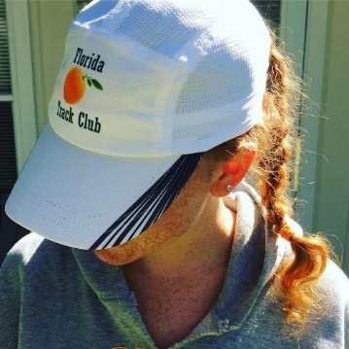

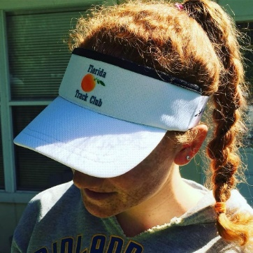

2019 Board of Directors
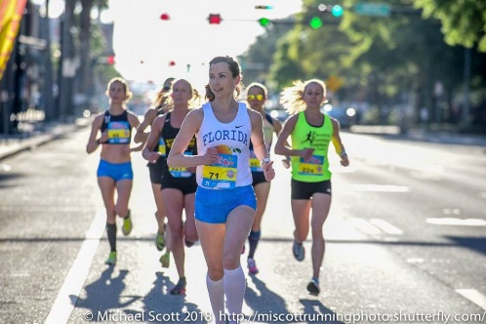

Betsy Suda, Executive Director
thefloridatrackclub@gmail.com

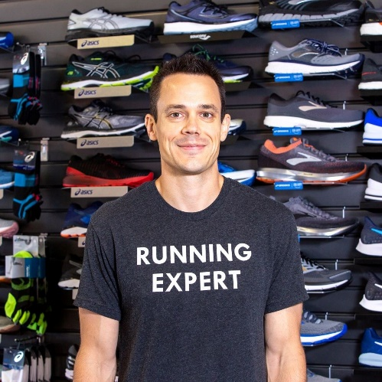
Michael Carrillo, President
mikeycarrillo@gmail.com

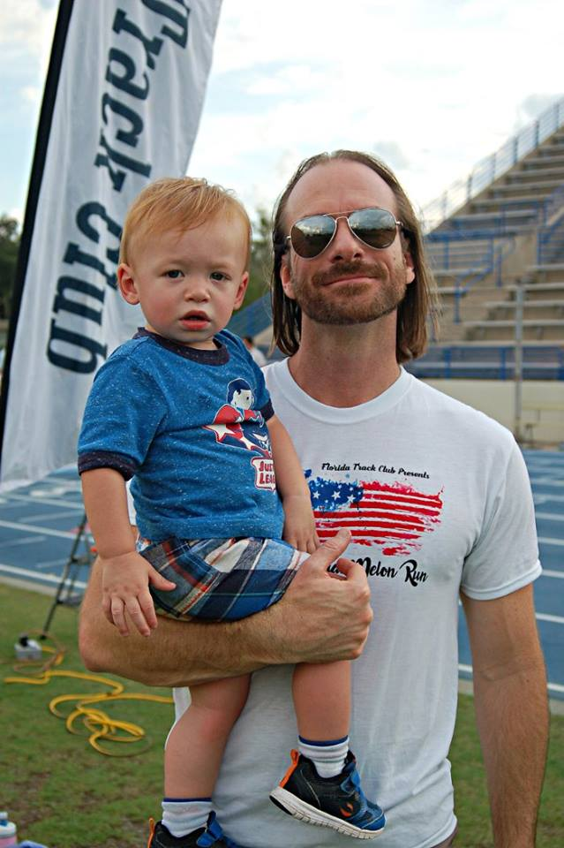
Richard Garand, Immediate Past President
rjgarand@gmail.com

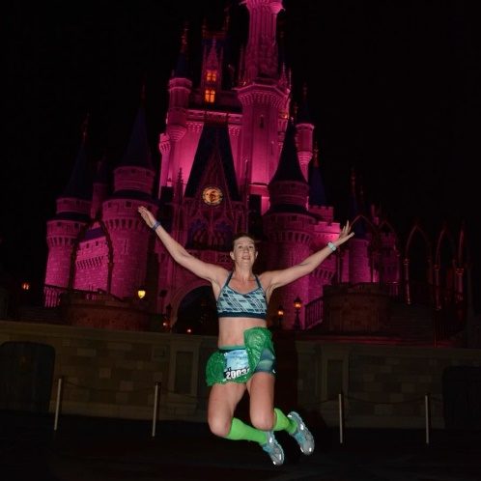
Gretchen Loyd, Vice President
Gretchen.loyd@gmail.com

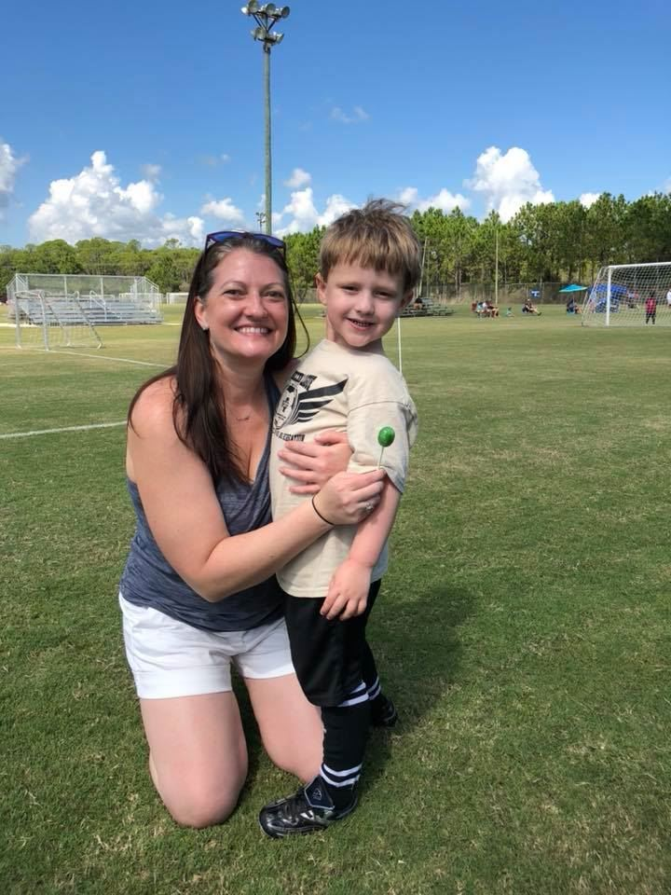
Marie Dennis, Treasurer
fsumarie@hotmail.com

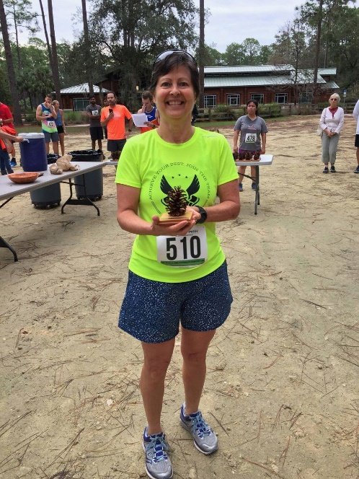
Robin Politowicz, Secretary
Robinp1561@gmail.com

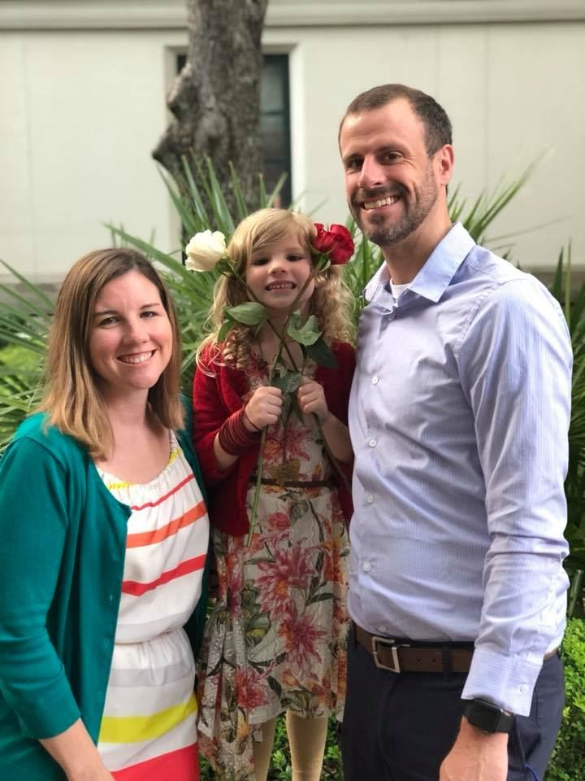
Nicolas Armfield, Director
narmfield@gmail.com

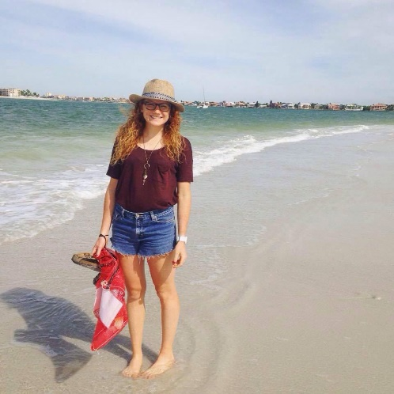
Courtney Rouse, Director
Rouseca11@gmail.com

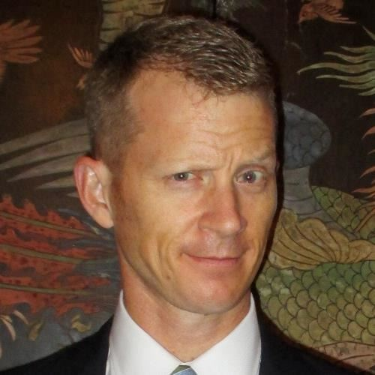
Andrew Ragsdale, Director
andrewmragsdale@gmail.com
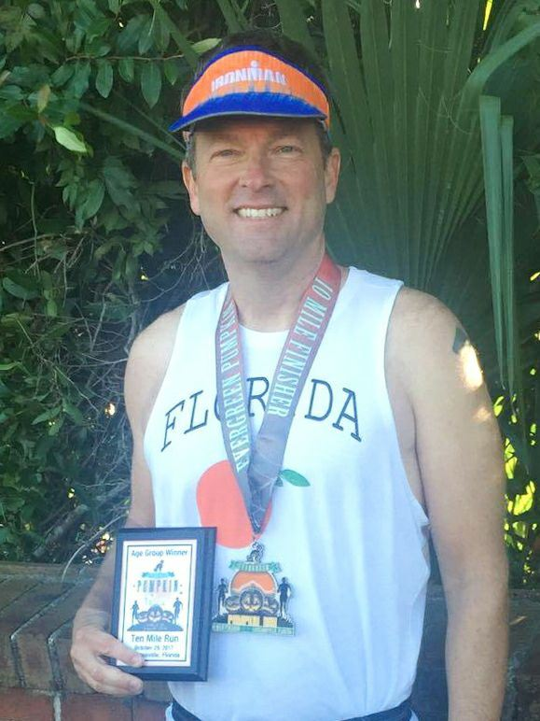
Soren Brockdorf, Director
cpasoren@hotmail.com

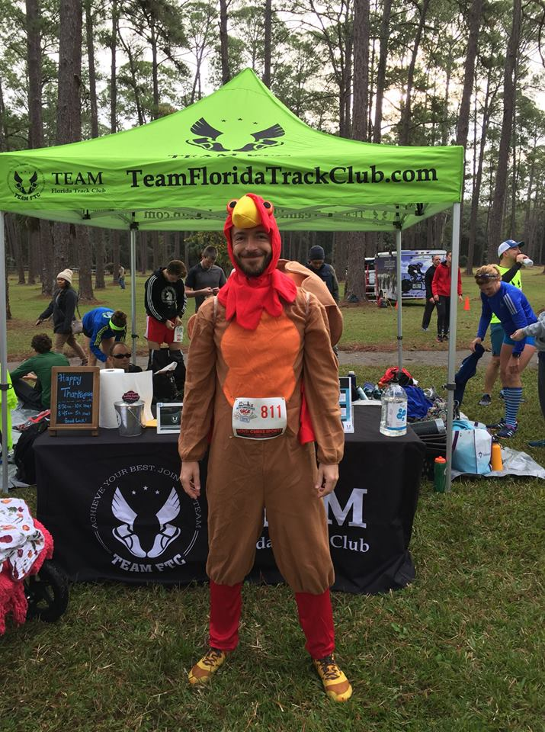
Dan Stoner, Director
danstoner@gmail.com

History of the Florida Track Club
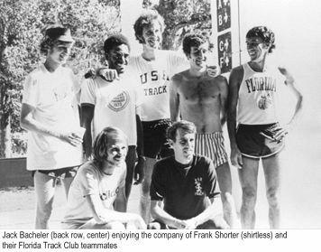
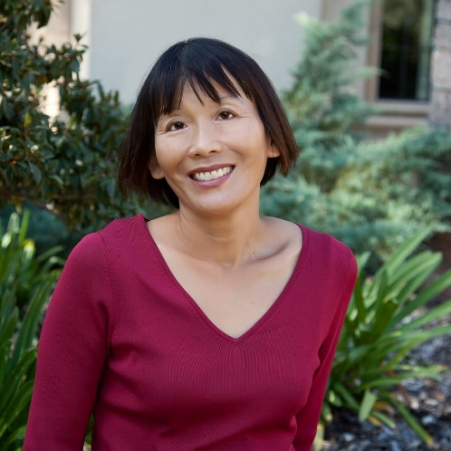
By Felicia Lee
felicialeewrites@gmail.com

Florida Track Club
The Florida Track Club (FTC) is the oldest continuously operating track club in the U.S.^{[6]} It is known not only as the home and training base for prominent runners such as Olympic gold medalist Frank Shorter, Jack Bacheler, and Jeff Galloway,^{[6]} but also for setting important precedents for modern track clubs: FTC was the first track club in the U.S. to be granted tax-exempt status, and the first in which competitive athletes had the majority vote on who would go to meets and where they would go.^{2]} FTC was also largely responsible for establishing its hometown, Gainesville, Florida, as a mecca for serious competitive runners.^{[6]}
The Beginning
FTC was founded in 1965 by University of Florida and Olympic track coach Jimmy Carnes and Jack Gamble in Gainesville, Florida. Upon moving to Gainesville in 1965 for his career in environmental engineering, Gamble, a former college track and field athlete who wanted to stay involved in the sport, reached out to Carnes and volunteered to officiate and otherwise help out at events. The two started an informal group in which Gamble would recruit prominent runners to give talks.^{[1]}
One day, Carnes asked Gamble if he could help raise money to send a team to a relay race at Madison Square Garden in New York—he’d been expecting a check, but it hadn‘t yet arrived. Gamble immediately started fundraising among other runners at the University of Florida and brought the money he’d acquired back to Carnes.^{[1]} However, by that time, the check Carnes had been expecting had arrived. Since most of the donations Gamble had solicited were in cash, and he hadn’t kept track of who had donated what, he couldn’t return the money. Carnes and Gamble felt obligated to put the funds to good use for the running community.^{[1]}
Gamble consulted with Ed Singley, a colleague from work who had experience setting up organizations and handling finances. By the end of the day, the Florida Track Club had come into being, with Carnes as its executive director, Gamble as its president, and a bank balance of around $800.^{[2]}
Soon after, Carnes and Gamble met with a number of other local runners at Gamble’s house to develop a plan and a vision for the club. Besides being accomplished runners, many of those attending this first meeting brought useful professional skills to the club’s founding.^{[2]}
One of them, John L. Parker, Jr., had a law degree and used his legal skills to draft an official charter for the club. (Parker’s novel Once a Runner, a cult favorite among runners, is a lightly fictionalized account of the early years of the club.)^{[4]} Another, Olympic distance runner Jack Bacheler, designed the club’s logo, an image of a Florida orange, making a point of ensuring the image in the logo was botanically accurate.^{[2]}
An innovative feature of the club was that it was organized so that a majority of the board would be competitive runners, and these runners would decide who got club support to attend meets and which races they’d attend. This strategy was designed to ensure the best athletes for each event would get support and avoid the political favoritism that occurred in other clubs. This policy was unique among track clubs of the time.^{[2]}
Gamble stayed president for about 3 years, after which time the club instituted regular elections.^{[1]}
The Early Years
During Carnes’ years coaching the club, he noticed his runners tended to be in better condition during indoors winter meets than runners from northeastern schools. He attributed this to Florida’s weather, which allowed for long outdoors workouts during the winter.^{[3]}
But Florida’s punishingly hot and humid summers also proved a useful training tool. In the 1968 Summer Olympics in Mexico City, Jack Bacheler, an early club member and top-ranked two-miler, was the only U.S. runner able to run strongly enough at Mexico City’s high altitude to qualify for the finals in the 10,000 meters.^{[3]} Unfortunately, he was selected for random drug testing after the qualifying race and when unable to produce a urine sample, was coaxed to drink some local water offered by race officials. The unpurified water gave him such severe digestive distress he was unable to compete in the finals.^{[3]}
Nevertheless, serious runners took note of Bacheler’s success in the preliminary races, which Carnes attributed to Bacheler’s training regime of two or three daily runs in Gainesville’s summer heat—this apparently gave him the conditioning he needed to run efficiently at high altitude. Other serious competitive runners, wanting to replicate his success, soon began moving to Gainesville and training with the FTC.^{[1]}
By the 1970s, the FTC had become the training home to such prominent runners as Jeff Galloway, Frank Shorter, and Barry Brown. In 1970, the year Shorter joined the FTC, the club won its first national championship at the Track and Field Federation meet. In 1971, FTC won its first AAU cross-country championship and retook the title twice, in 1972 and 1973.^{[5]}
After Shorter took the gold medal in the marathon in the 1972 Summer Olympics in Munich, the club’s popularity exploded—as did serious interest in long-distance running. It was during this era that Gainesville became known as a mecca for elite competitive runners.^{[1]}
At this time, competitive running adhered to a code of strict amateurism—runners could not receive any compensation for their running apart from payment of their expenses. The mere suggestion of an improper gift or excessive reimbursement of expenses was sometimes enough to get a runner banned from competition. To help FTC runners support themselves while adhering to this standard, Gamble arranged part-time landscaping maintenance jobs for them with UF’s Plant and Grounds Department. He also arranged for local hotels to let runners stay in unoccupied rooms. Carnes, who owned some investment properties in Gainesville, opened some of them to runners as well. In addition, Gamble even had some runners stay with him in his own home when first arriving in Gainesville.^{[1]}
On top of his running achievements, Shorter also changed track and field history by forcing a change in the longstanding policy of strict amateurism for runners. After becoming a household name, he began manufacturing and selling running gear and pushed back when told he couldn’t wear one of his own branded shirts.^{[1]} Realizing the absurdity of this constraint, officials relented, and the policy of strict amateurism soon ended, paving the way for today’s professional running circuit.^{[1]}
Women in the Early FTC
While the initial group of runners in the club were men, a few serious female runners were also active members of the club in its early years. The most prominent of these was Margaret Tolbert, who, along with her sister, Jane, had been tennis players UF, but also had an interest in running. Opportunities for women to run competitively at the college level were limited at the time, and the longest race available to them was 1 mile, which put Tolbert, whose aptitude was for distance running, at a disadvantage.^{[1]} Moreover, track training for women was constrained by the small number of women interested in running as well as conventional standards of femininity.^{[6]}
The FTC runners, however, were welcoming and supportive of her efforts, and she made a point of keeping up with them in their workouts.^{[6]} This was initially a challenge, since she started running with them in her teens and most of the other runners were men in their mid-20s. In addition, she participated in an informal group of noon runners that included FTC members and non-members and both men and women.^{[6]} This experience offered her access to cutting-edge training as well as the financial support to compete in prominent races. Because of her rigorous training and mentoring from other FTC members, she won most races she entered, including several national titles. Among her victories were the SEC 880 and mile, a women’s half-marathon, and the Stone Mountain Road Race two years in a row. She also was the first woman to serve on the board of the FTC. ^{[6]}
The FTC, Robert Cade, and the Development of Gatorade
Another early contributor the club was UF medical researcher Robert Cade, who led the team that invented Gatorade. While developing the still-unnamed sports drink, which was intended to promote better endurance and prevent dehydration in athletes, he tested it on UF and FTC runners.^{[7]} At one relay marathon, he set up tents at set points along the course, where his researchers took blood samples from runners, comparing those from runners who had consumed his formula to those from a control group. These findings contributed to the refinement of his formula.^{[7]}
Cade was active in the FTC and in Gainesville’s running community in general. A former competitive runner,^{[7]} he believed strongly in the health benefits of running, and was often seen running with his six children, with whom he formed an informal “track club”, complete with matching t-shirts, he dubbed “Plumbous Pedis” (“lead foot” in Latin).^{[6]} Cade was instrumental in the development of several local running programs, including the Great Gainesville Road Race, a prominent 5K in the 1980s and 1990s, as well as FTC’s Junior Champ program, an age-grouped youth program that introduces boys and girls to track and field events.^{[6]} Cade has been called “the quiet, unassuming guardian angel of the Florida Track Club…He has also been the silent benefactor to more than several developing runners who needed a little extra assistance to go from good to great.”^{[9]} In 1990, the FTC inaugurated an annual Cade Prize, to be awarded to a club member who had rendered extraordinary service to the club in the previous year. ^{[9]}
The 1970s Running Boom and the Transformation of the FTC
After Shorter’s victory in the 1972 Olympics, distance running captured the public imagination and running became a popular mainstream activity. During this time, recreational runners, most new to running, began joining the FTC. This changed the profile of the club from one populated purely by elite competitors to one serving both serious competitors and novices.^{[8]}
This led to some tension between the two groups. While FTC continued its original mission of training and supporting elite runners, some of the recreational runners felt their interests weren’t being properly addressed by the club—they wanted to club to organize more road races and other activities for the community at large rather than focus the club’s resources on competitive training and track meets. Moreover, as the club’s superstar runners of the early 1970s started to retire, some questioned the club’s heavy investment in the less-storied competitors who followed.^{[8]}
To support the elite runners, sports broadcaster, Gainesville entrepreneur, and former Olympic runner Marty Liquori began sponsoring a team affiliated with the FTC through Athletic Attic, a chain of running shoe shops that he had co-founded in 1973. (While Liquori lived in Gainesville and trained with FTC runners, he remained sponsored by—and under contract to—the New York Athletic Club, so was never an official member of the FTC).^{[1,10]} The Athletic Attic/FTC team, as it was first known, was the first athletic team to be named after a corporate sponsor.^{[10]} Athletic Attic provided its runners part-time jobs at its local branch, as well as financial support for travel to races.^{[1,10]}
Some FTC members, however, were uncomfortable with what they perceived as the commercialization of the club. The Athletic Attic team then disassociated itself from FTC and became an independent team.^{[10]}
In 1978, a group of recreational runners decided to form a separate organization, the Florida Road Runners, which would focus on road races and other activities for recreational runners. True to its name, the FRR organized numerous road races, which attracted large numbers of local runners.^{[8]}
Within a few years, however, the FTC had independently chosen to shift more of its focus onto the growing population of recreational runners and started organizing road races of its own. By 1980, both groups were regularly hosting weekend races and even found themselves hosting overlapping races.^{[8]}
David Mathia, one of the leaders of the FRR, realized the groups had come to share the same mission and constituencies and thus were duplicating many of their efforts. For this reason, he reached out to Len Ryan, the president of the FTC at the time, and proposed a merger of the clubs.^{[8]} Ryan agreed, and by 1981, the clubs had merged memberships and the FRR had been reabsorbed into the FTC. Following the merger, Mathia became FTC’s race coordinator.^{[8]}
The Rise of Road Racing
Throughout the 1980s, the FTC grew increasingly active in organizing road races. As both a community service and a fundraising effort, the club started organizing races for local charities and community groups. The club would be paid a stipend by these groups, and in return, would take charge of both planning the races and recruiting race sponsors.^{[8.10]}
By the late 1980s, running had become a high-profile sport, and most major cities sponsored high-profile road races. Wanting to draw more attention to Gainesville’s running community, in 1990, Marty Liquori and University of Florida track coach Hal Rothman organized the Great Gainesville Road Race (GGRR), which they envisioned as an annual 5K for both elite competitors and recreational runners.^{[1,10]} Liquori asked Gatorade inventor Robert Cade, who was active in the running community, to provide seed money. To build buzz around the event, Liquori also asked the FTC not to schedule any races in the month before and two weeks following the GGRR.^{[1,10]}
In its inaugural year, the GGRR included two races—an earlier race through downtown Gainesville for professional runners, and a later race through a nearby residential neighborhood for recreational runners.^{[1,10]} Race organizers recruited prominent runners to the race. Among these were members of the Norwegian national track team, who had been encouraged to participate by Norwegian marathoner Grete Waitz, a five-time world champion who trained part-time in Gainesville and participated regularly in FTC activities.^{[10]} (Waitz herself was unable to run with the elite competitors because of an injury, but along with Keith Brantly, another injured top-ranked runner, ran in the later race with the recreational runners.)^{[11]}
After the first few years of the GGRR, Rothman and Liquori were ready to move on to other ventures, and ceded control of the race to the FTC.^{[10]}
Over time, however, prize purses for professional runners grew, along with the number of high-profile opportunities for them to compete. The GGRR was eventually unable to offer either enough prize money or prestige to attract top runners, and moreover, the now-crowded professional race schedule meant it often conflicted with more popular events.^{[10]} The growth of recreational racing opportunities also meant the GGRR competed against other local races.^{[10]} Thus, the GGRR was discontinued in the early 2000s.
However, the FTC continued to sponsor a series of popular regular races, including the Newnans Lake 15K (which many runners used as a warm-up race for the 5 Points of Life Marathon and Half-Marathon typically held a few weeks later), a half-marathon, and the July 4 Melon Run, one of FTC’s oldest traditions.^{[1]} While the FTC had a regular marathon training group and members regularly participated in out-of-town marathons. The Five Points of Life Marathon was first organized in 2006^{[12]}
While the majority of FTC members in this era were recreational runners, elite competitors as well as serious amateurs continued to compete in FTC races. Thus, race organizers took care to measure the courses accurately to ensure that participants could use their times to qualify for elite races such as the Boston Marathon.^{[13]}
The FTC Today
Today, the FTC continues to serve both recreational and elite runners, and currently boasts over 300 members.^{[14]} It has also expanded its mission to educating the community at large about running, and thus has expanded its activities to accommodate runners of all ages and abilities.^{[14]} Among its popular current activities are the annual 4th of July Melon Run (3 miler), the Tom Walker Memorial Half-Marathon and 5k (typically held around Veteran’s Day, the June Twilight Track Meet held at the University of Florida, which includes track and field events for competitors of all ages, and the Frank Shorter Road Mile, a New Year’s Day road race on a USATF certified course. In addition, FTC members regularly volunteer as pacers for the annual Five Points of Life Marathon in Gainesville.^{[14]} FTC also has a series of regularly scheduled group runs open to the public as well as monthly talks by prominent members of the running community.^{[5]}
In 2015, FTC began offering scholarships to help cover the travel expenses of members participating in out-of-town races.^{[14]} Unlike the funding provided to runners in the early days of the FTC, these scholarships are available to recreational as well as elite runners. (The only requirement is that recipients wear the FTC singlet when racing and report back on their experience at the FTC’s monthly meeting.)^{[5]} As of 2017, over 20 scholarships have been awarded.^{[14]}
Prominent Runners Affiliated with the FTC
Over the years, a number of prominent competitive runners have trained with the FTC. While not all were official members of the club, all trained at least part time in Gainesville and participated in FTC activities.
- Jack Bacheler (National AAU champion, cross country and 10,000 meters 1969; national AAU champion, 6 miles, 1970)^{[16]}
- Barry Brown (first place, Price Chopperthon, 1983; first place, Adirondack Distance Run, 1983, 1984, 1987; first place, World Veterans Championship, 1984; first place, TAC Masters Road Championships, 1985)^{[17]}
- Keith Brantly (first place, World University Games, 10,000 meters, 1981; first place, US 10,000 meter Road Championships, 1985, 1987, 1989, 1995; first place, first place, US 20 km Road Championships, 1993; US 25 km Road Championships, 1995; first place, US Marathon Championships, 1995, 1998)^{[18]}
- Byron Dyce (bronze medal, 800 meters, 1971 Pan-American Games)^{[19]}
- Jeff Galloway (member, US Olympic team, 1972; US record-holder, 10-miles, 1973)^{[20]}
- Marty Liquori (NCAA and AAU outdoor mile champion, 1969 and 1971; AAU outdoor mile champion, 1970; gold medalist, 1500 meters, Pan-American Games, 1971; world champion, 5000 meters, 1977)^{[21]}
- John L. Parker, Jr. (three-time Southeastern Conference champion, 1 mile; US Track and Field Federation champion, steeplechase)^{[22]}

- Frank Shorter (world champion, marathon, 1971, 1972, 1973; US champion, marathon, 1971, 1972, 1973, 1974, 1976)^{[23]}
- Grete Waitz (first place, IAAF World Cup, 3000 meters, 1977; first place, World Cross Country Championships, 1978. 1979, 1980, 1981, 1983; first place, New York City Marathon, 1978, 1979, 1980, 1982, 1983, 1984, 1985, 1986, 1988; first place, London Marathon, 1983, 1986)^{[24]}
Guest Speakers
The FTC holds monthly meetings in February, March, April, September, October, and November. During the other months, the club holds fun runs finishing at local eating establishments, where members are treated to refreshments. Some of the esteemed speakers the club has hosted include the following:
- Keith Brantly (1996 US Olympian Marathon) ^{[25]}
- Todd Williams (1992 & 1996 US Olympian 10,000 meters, founder of RunSafer)^{[26]}
- Brian Sell (2008 US Olympian Marathon)^{[27]}
- Kim Pawelek (1999 US Marathon Champion, multiple US Olympic Marathon Trials Qualifier^{[28]}
- Mike Holloway (University of Florida Track and Field and Cross-Country Head Coach)^{[29]}
- Jeremy Foley (former University of Florida Athletic Director)^{[30]}
- Luke Watson (NCAA All-American from Notre Dame, multiple US Olympic Trials Qualifier: 3,000 meters steeplechase, 5,000 meters, and Marathon, member of Team USA World Cross-Country)^{[31]}
- Dr. Robert Cade (developer of Gatorade)^{[32]}
- John L. Parker Jr (Author of Once a Runner) ^{[33]}
- Hal Higdon (Runner’s World contributor, multiple Olympics Trials Qualifier, World Masters Champion, founder of Road Runners Club of America)^{[34]}
- Bart Yasso (Runner’s World Chief Running Officer) ^{[35]}
- Nicholas Romanov (developer of Pose Running Method)^{[36]}
- Mike and Debbie Cotton (US Champion Pole Vaulter) ^{[37]}
- Matt Fitzgerald (Author, Coach)^{[38]}
- Dennis Mitchell (1992 & 1996 US Olympian, 100 meters, 4X100 meter relay^{[39]}
References
- Jack Gamble, p.c.
- Florida Track Club newsletter, July 2015 (article by Jack Gamble)
- Florida Track Club newsletter, August 2015 (article by Jack Gamble)
- https://en.wikipedia.org/wiki/John_L._Parker_Jr.
- FTC membership application brochure

- Margaret Tolbert, p.c.
- http://www.nytimes.com/2007/11/28/business/28cade.html
- David Mathia, p.c.
- Florida Track Club newsletter, May 1990
- Marty Liquori, p.c.
- Florida Track Club newsletter, March 1990
- Florida Track Club newsletter, January 2006
- David Greenberg, p.c.
- Betsy Suda, p.c.
- http://teamfloridatrackclub.com/
- https://en.wikipedia.org/wiki/Jack_Bacheler
- http://more.arrs.net/runner/5675
- https://en.wikipedia.org/wiki/Keith_Brantly
- https://en.wikipedia.org/wiki/Byron_Dyce
- https://en.wikipedia.org/wiki/Jeff_Galloway
- https://en.wikipedia.org/wiki/Marty_Liquori
- Author bio, Again to Carthage, John L. Parker, Jr. 2007
- https://en.wikipedia.org/wiki/Frank_Shorter
- https://en.wikipedia.org/wiki/Grete_Waitz
- FTC newsletter, December 1999
- https://en.wikipedia.org/wiki/Todd_Williams_(athlete)
- https://en.wikipedia.org/wiki/Brian_Sell
- http://www.nydailynews.com/archives/sports/long-run-marathon-article-1.933994
- http://floridagators.com/coaches.aspx?rc=133
- FTC newsletter, May 1995
- https://en.wikipedia.org/wiki/Luke_Watson
- https://en.wikipedia.org/wiki/Robert_Cade
- FTC newsletter, April 1999
- FTC newsletter, February 1996
- http://www.bartyasso.com/
- FTC newsletter, January 1995
- https://en.wikipedia.org/wiki/Mike_Cotton_(pole_vaulter)
- https://mattfitzgerald.org/
- https://en.wikipedia.org/wiki/Dennis_Mitc

Club Member Benefits!
We are pleased to announce the following local businesses have recently extended 20% off discounts to FTC members!

Thank you to our generous club sponsor:
http://www.ortho.ufl.edu/

